**Photologic Experiment Rig SOP**

1. Ensure that the rig door is in the correct (UP) position as in Figure 1.

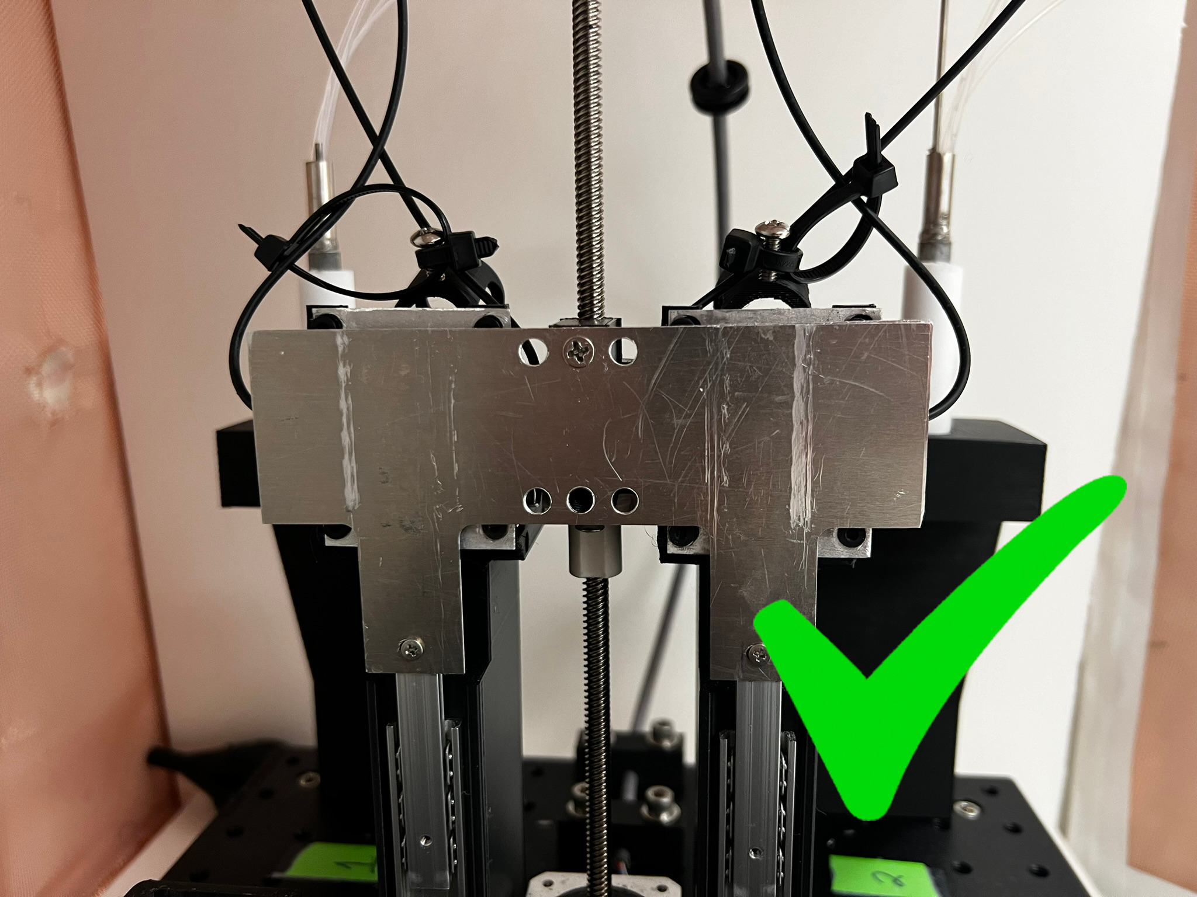

Figure 1

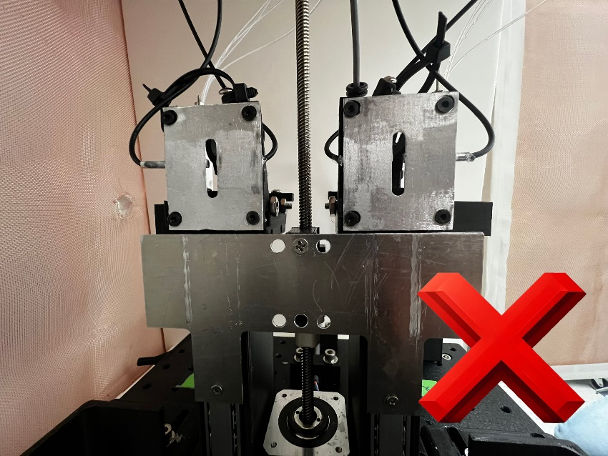

Figure 2

* 1. If the door is not fully up as in Figure 1, reset it manually by twisting the metal rod counterclockwise until the door is all the way at the top and the rod will no longer spin. Once the door has reached this top position, lower it slightly by twisting the rod clockwise ¼ of a turn as shown below.

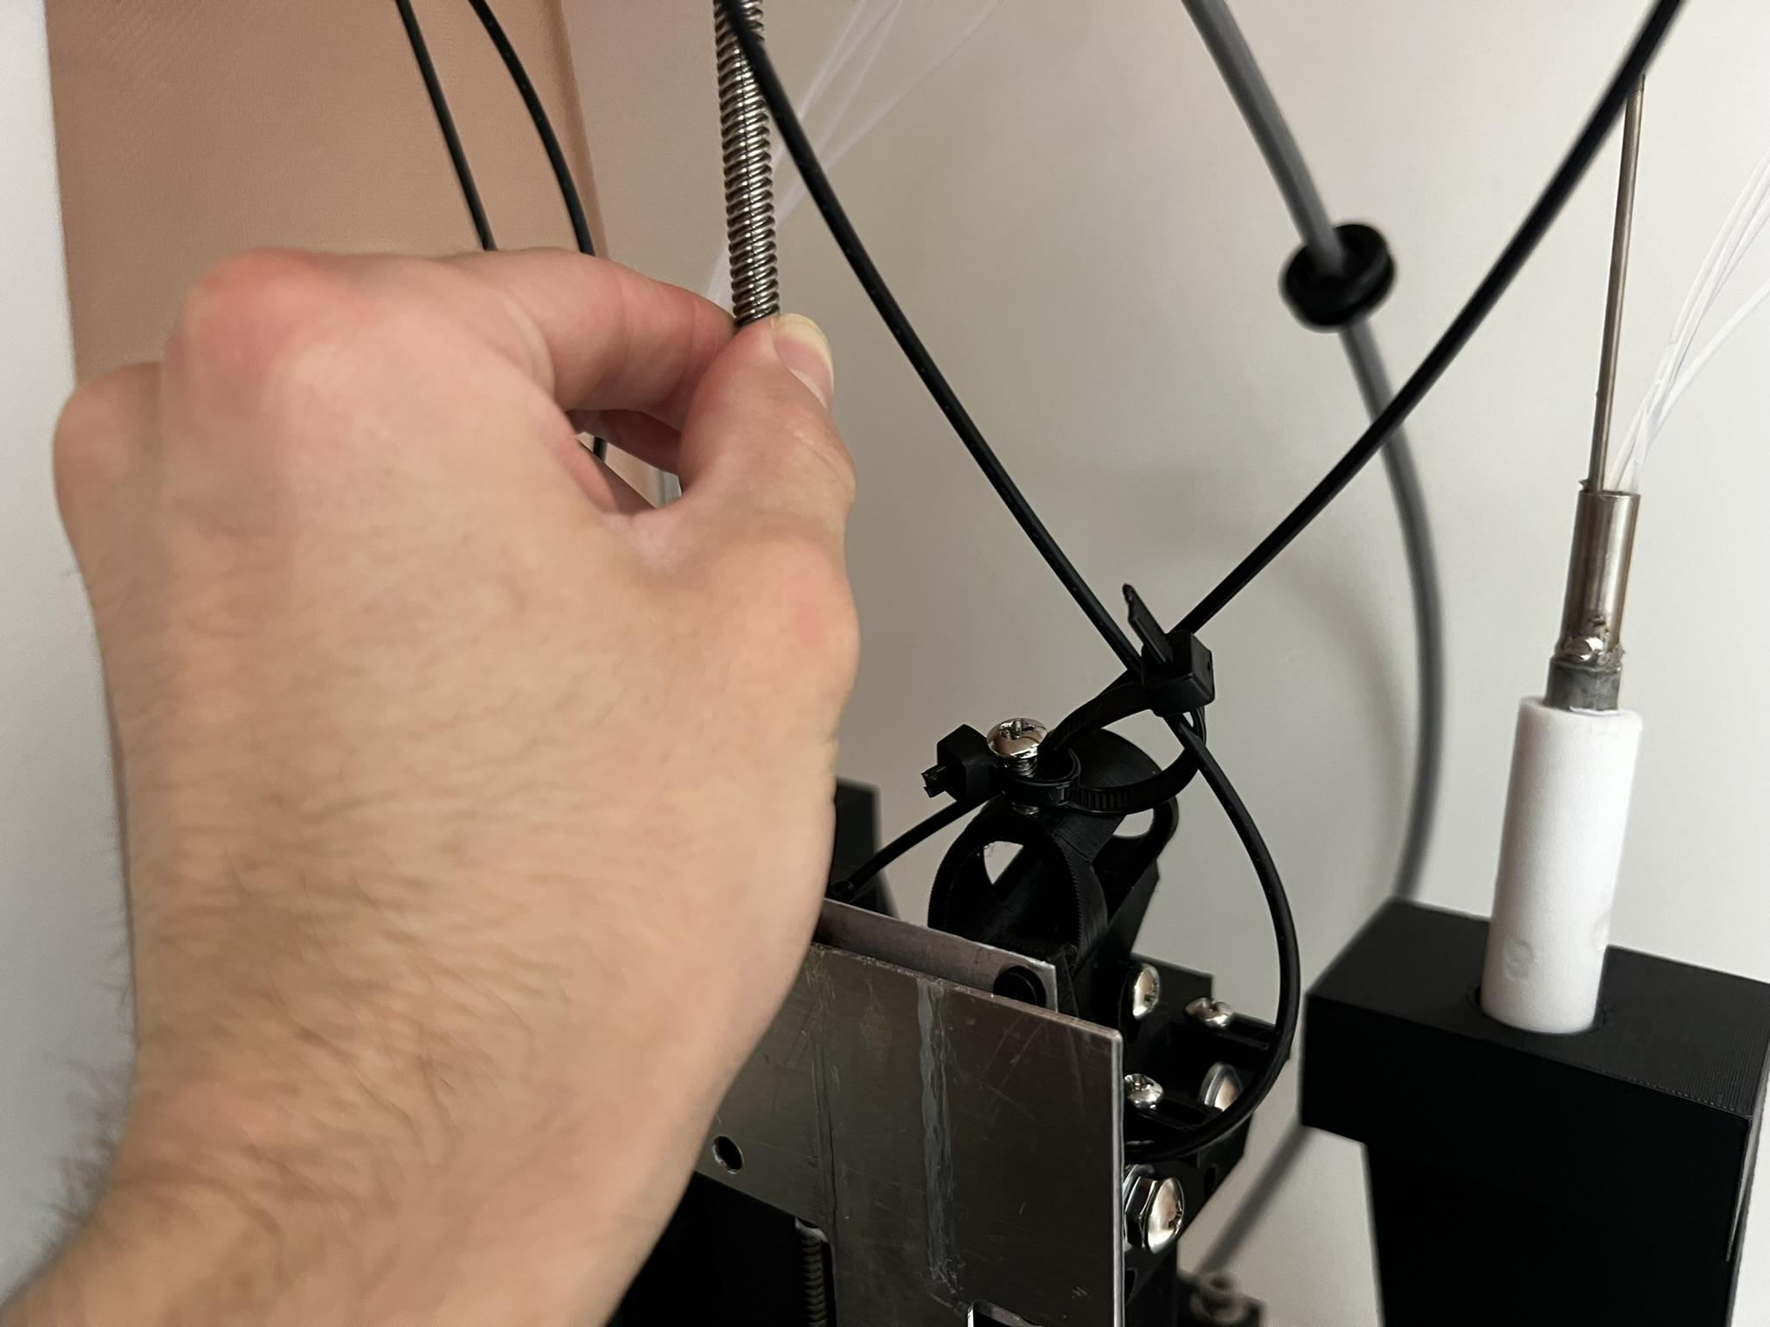

Figure 3

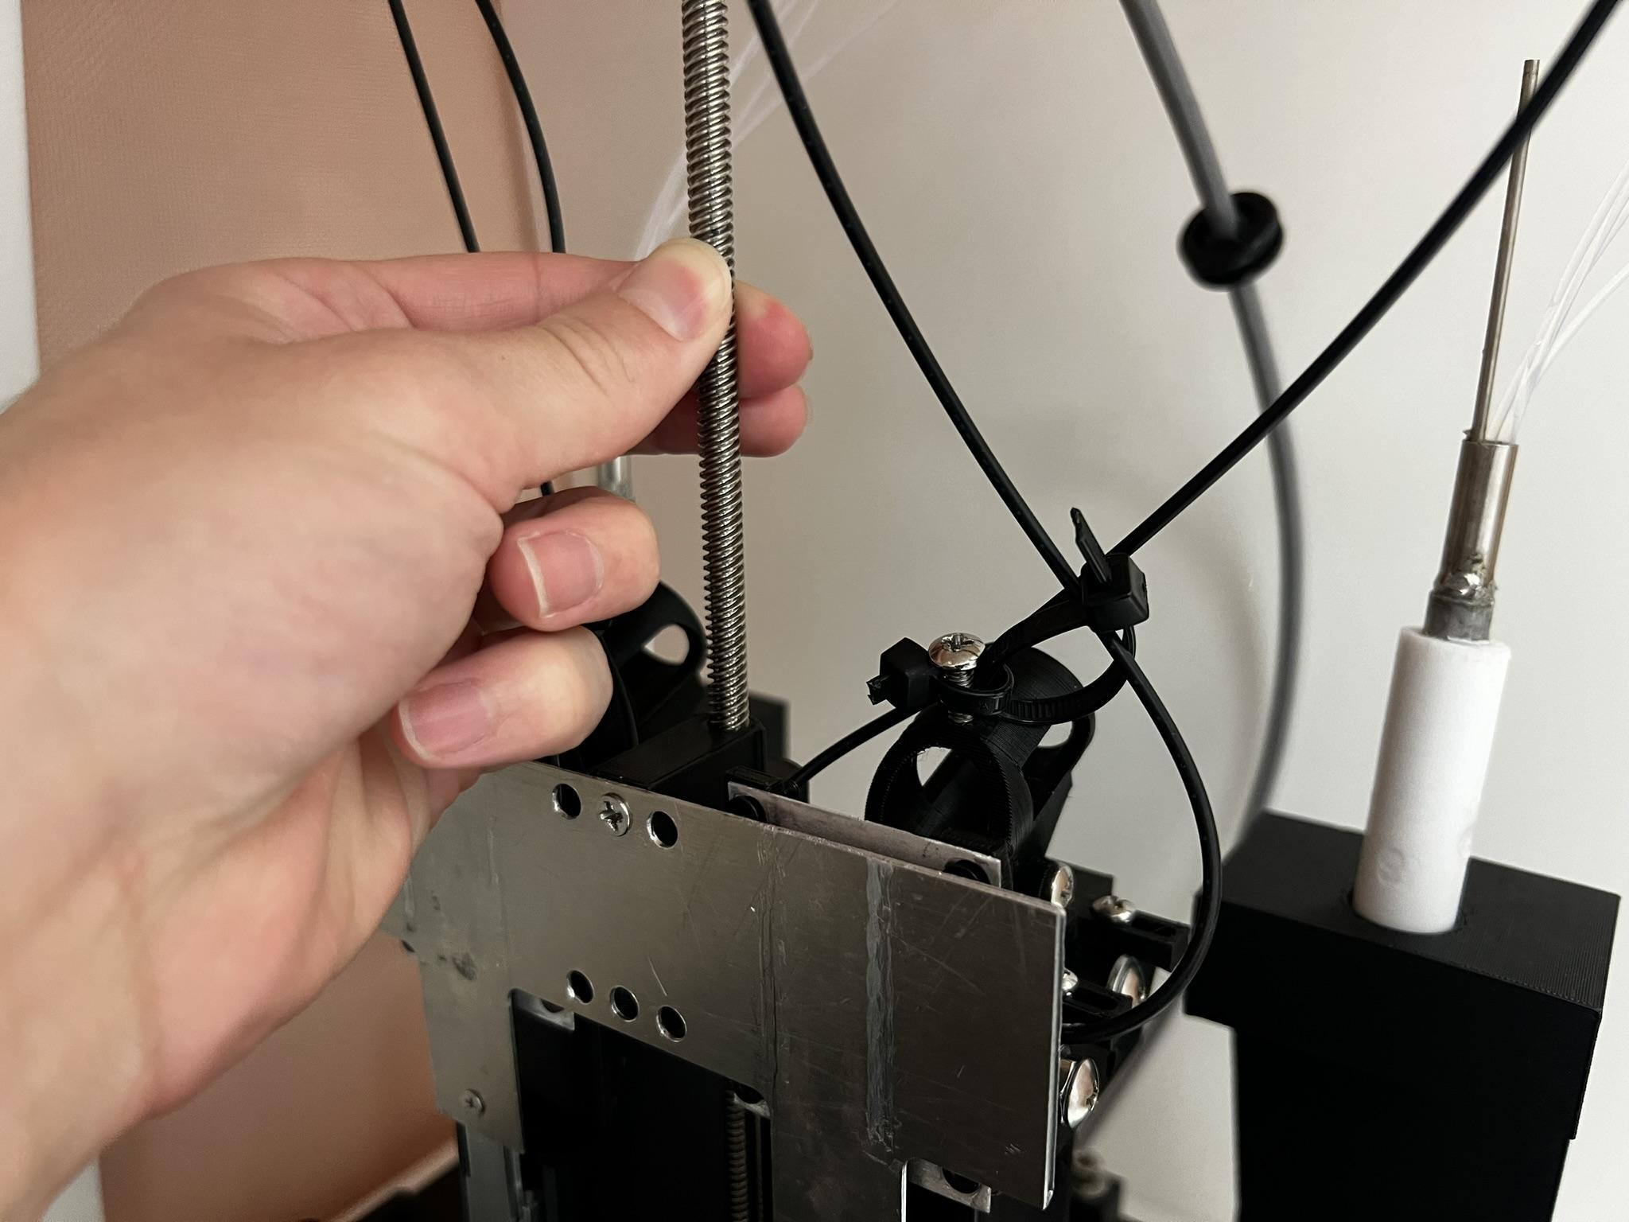

Figure 4

1. Turn the power strip ON. Then, turn the laptop ON using the small pulsing led button on the right side.

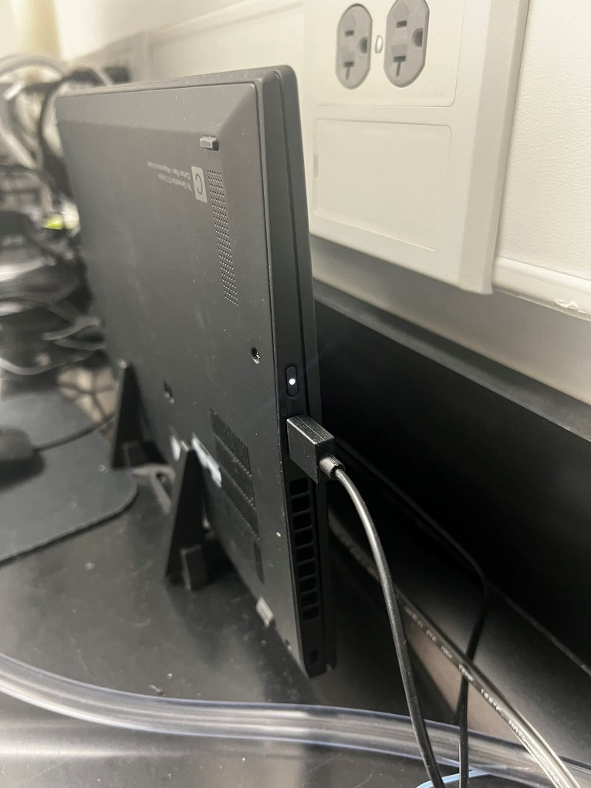

Figure 5

1. Activate the Hantek power supply’s display by flipping the switch to the UP position on the back of the unit. The switch location is shown in Figure 6.

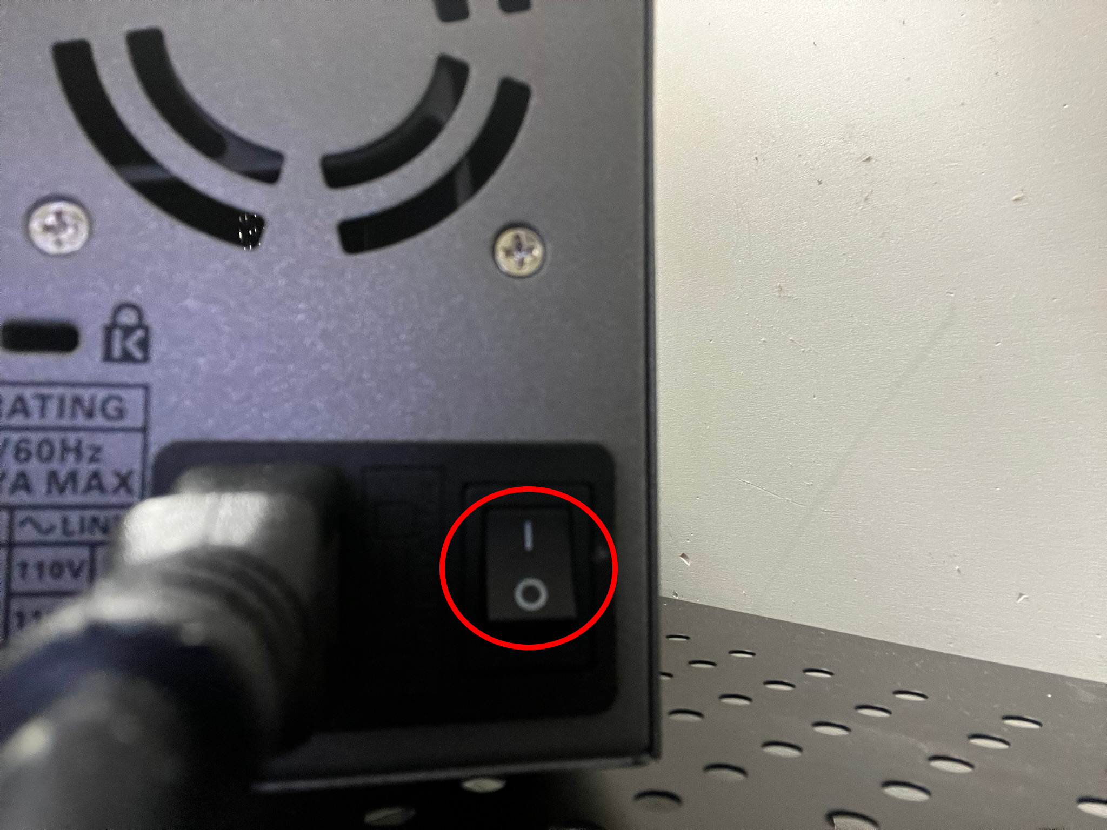

Figure 6

1. Ensure that the RED voltage lettering displays 12.00V, and the GREEN maximum current letting displays 2.800A as in Figure 5.
   1. If the settings are not configured at these values, then push the dial(s) of the setting(s) that are incorrect and twist the dial(s) until they match the values as shown in Figure 5.

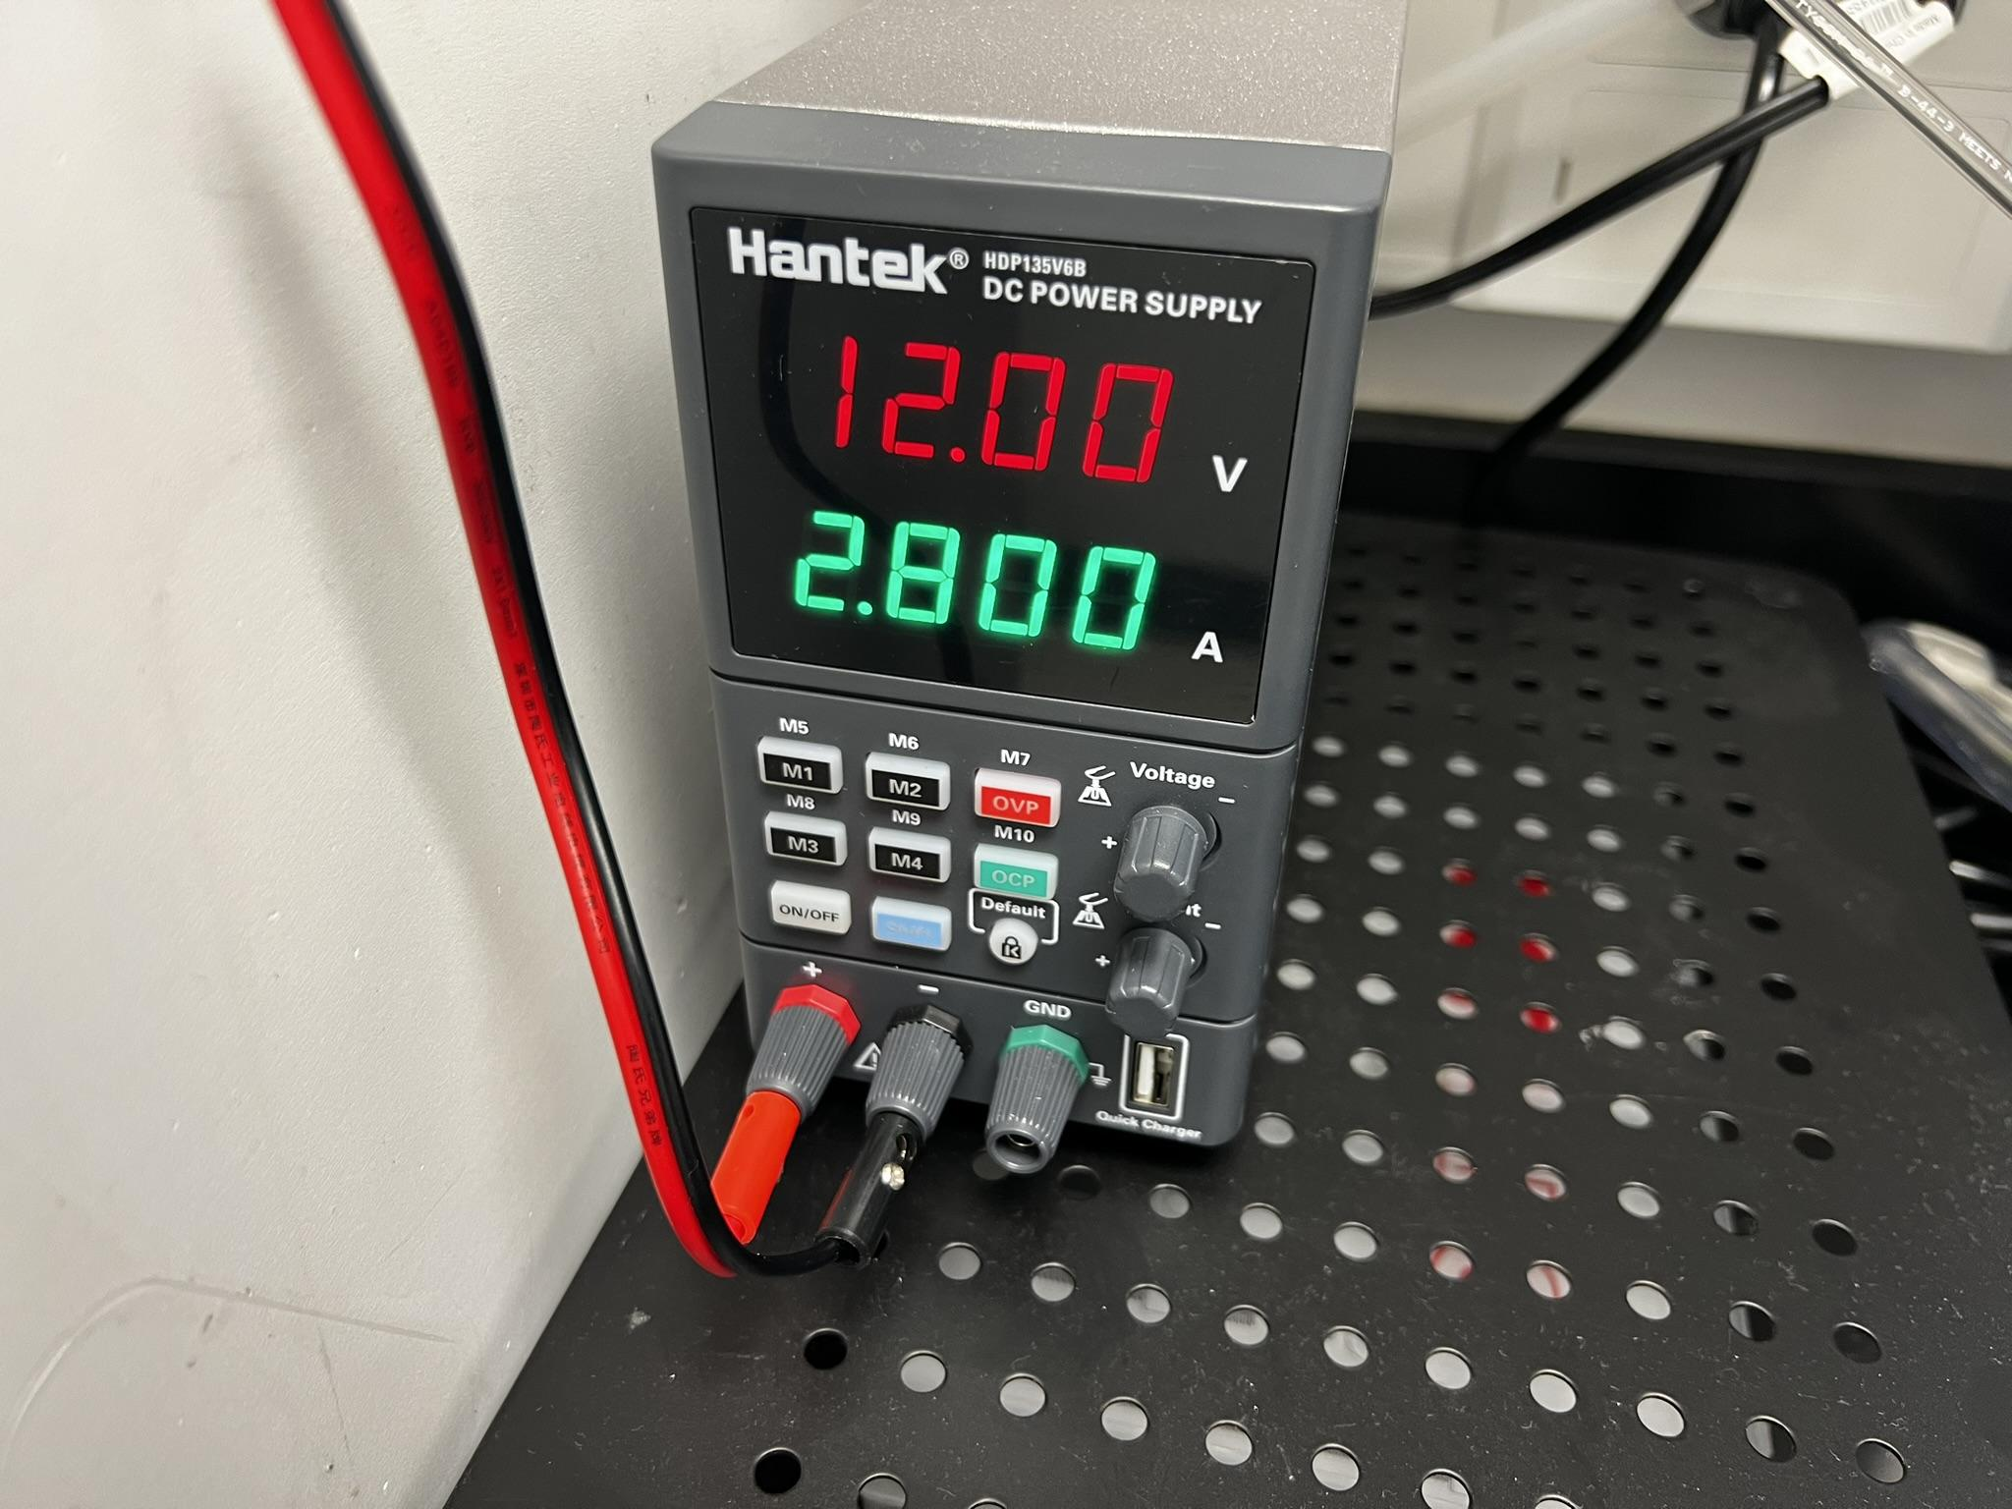

Figure 7

1. Press the *ON/OFF* button on the front, the button will light up green as shown in Figure 8 when activated.

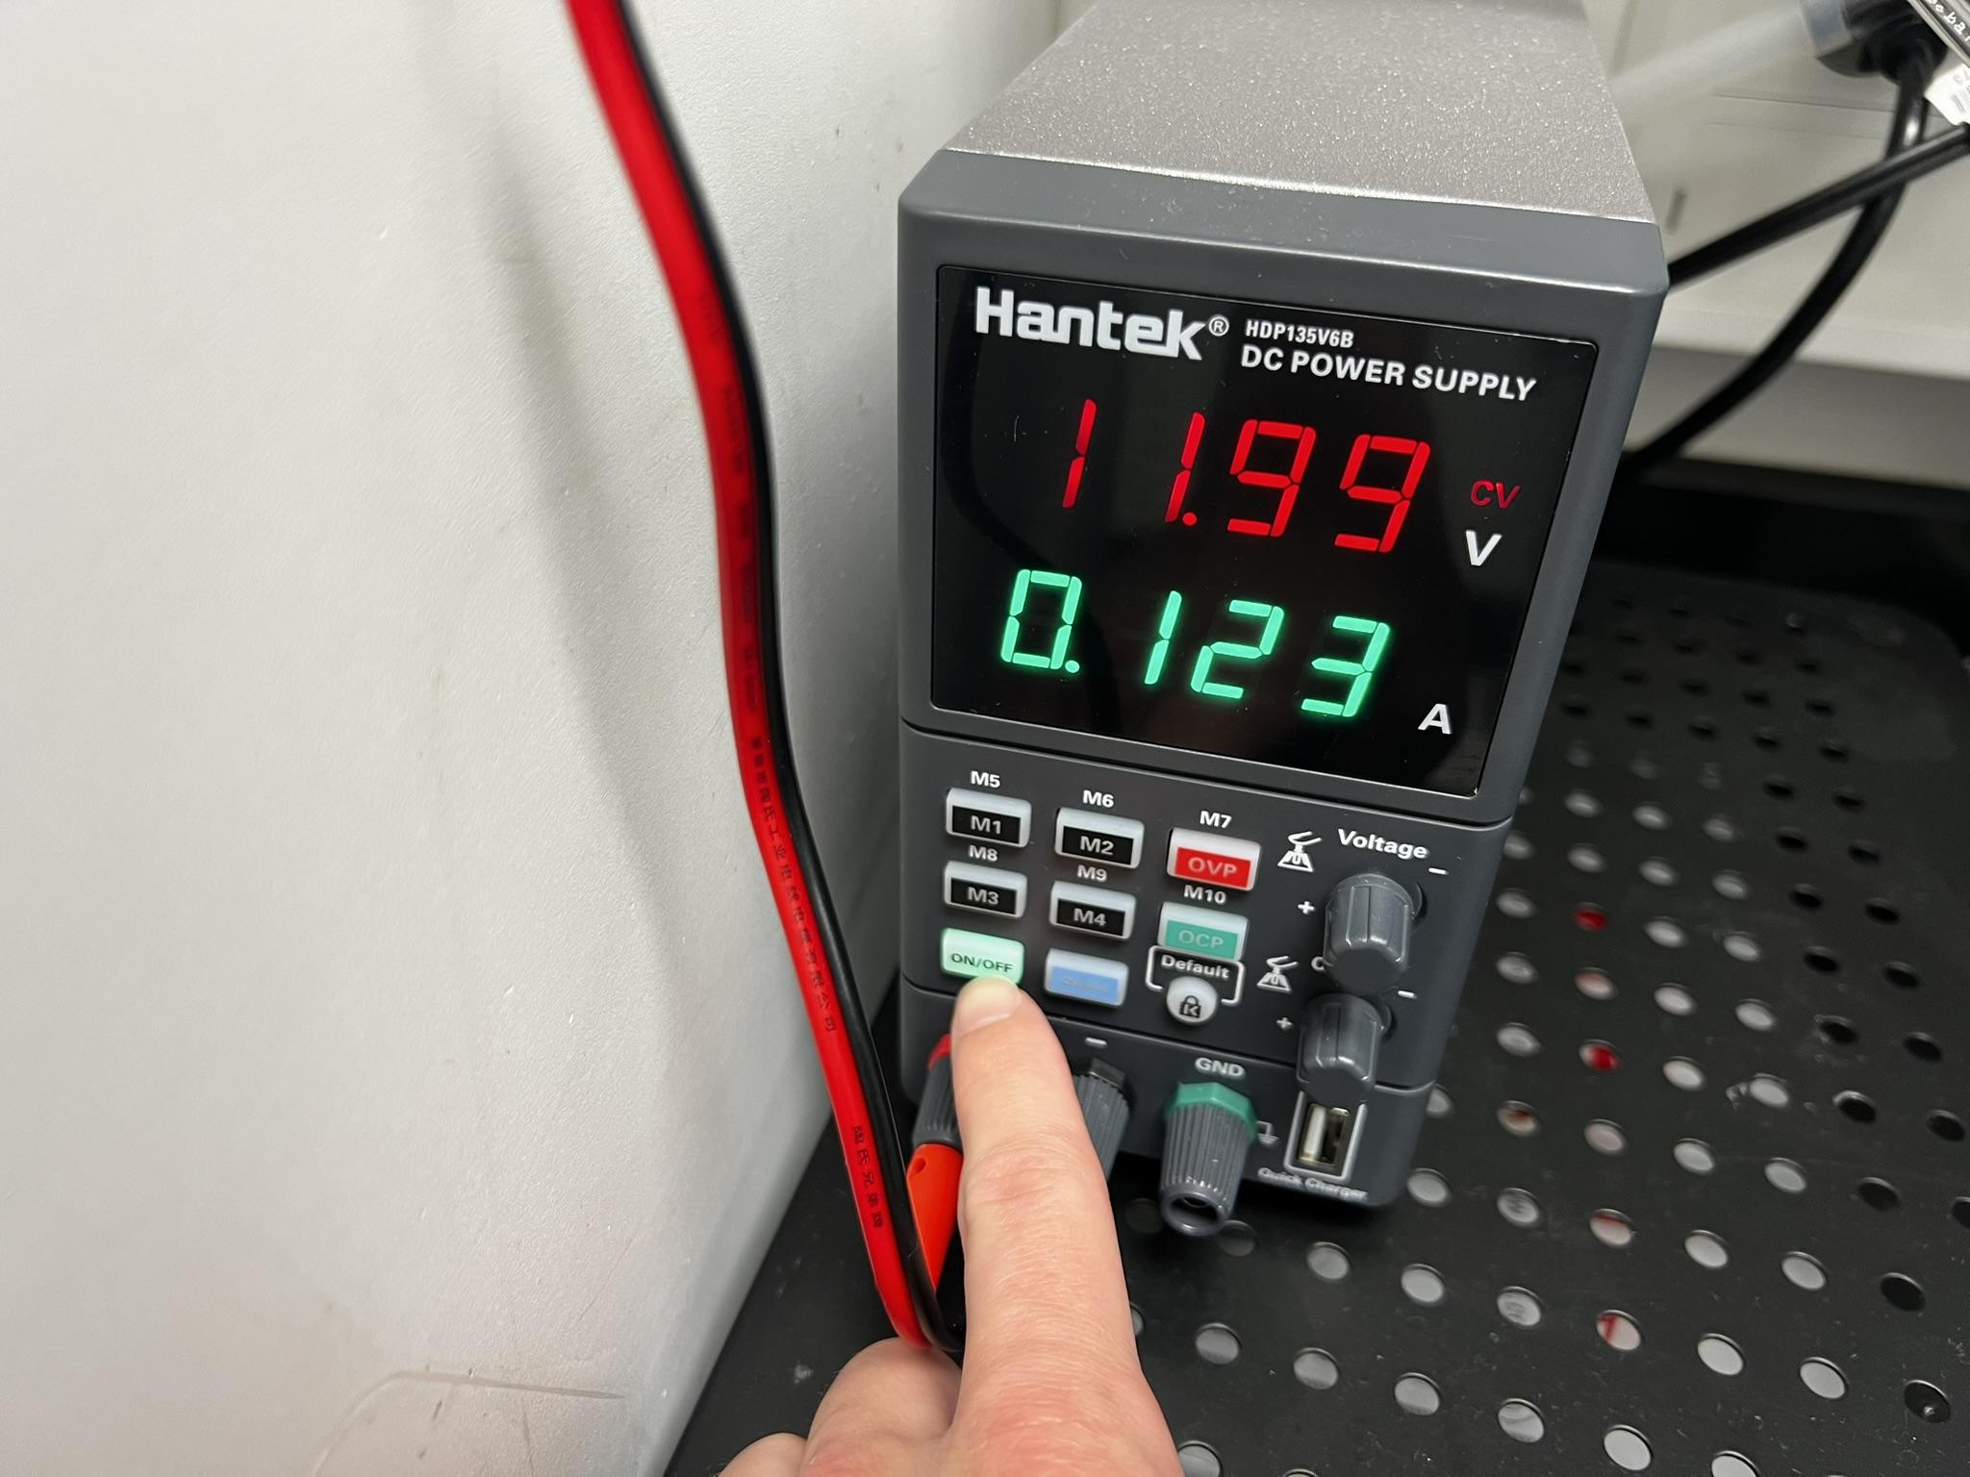

Figure 8

1. Launch the Photologic Experiment Rig control software by clicking the rat icon on the desktop or in the taskbar at the bottom of the display. These images are shown in Figure 9 and Figure 10. If the software successfully launches, you will see the screen shown in Figure 12 with no error message popups.
   1. If an ‘Arduino Error’ message as shown in Figure 11 appears, click *ok* and refer to the ‘Common Errors and Troubleshooting Guide’ at the end of this document.



Figure 9

Figure 10

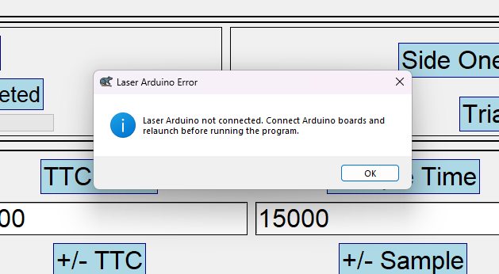

Figure 11

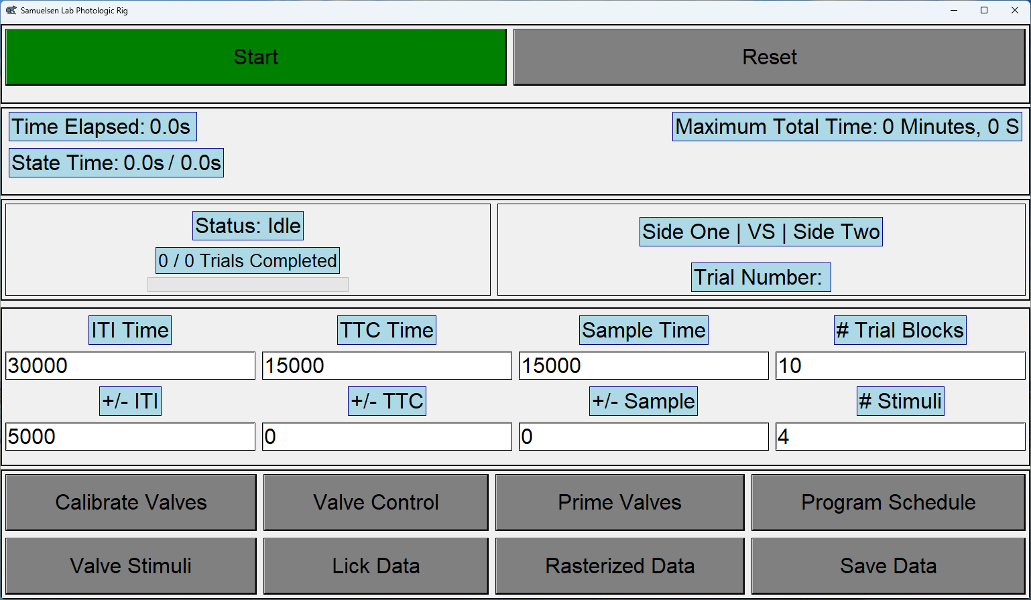

Figure 12

1. Fill the columns with the stimuli for your experiment. Ensure each unique stimulus fills two columns. For instance, if you use four unique stimuli, distribute them across all eight columns, with each stimulus repeated once for each lick spout. It is crucial to pair the stimuli such that the contents of valves 1 & 5, 2 & 6, 3 & 7, and 4 & 8 are identical. Refer to Figure 10 for an example of how valves are paired. Note these positions for when refills are needed later.

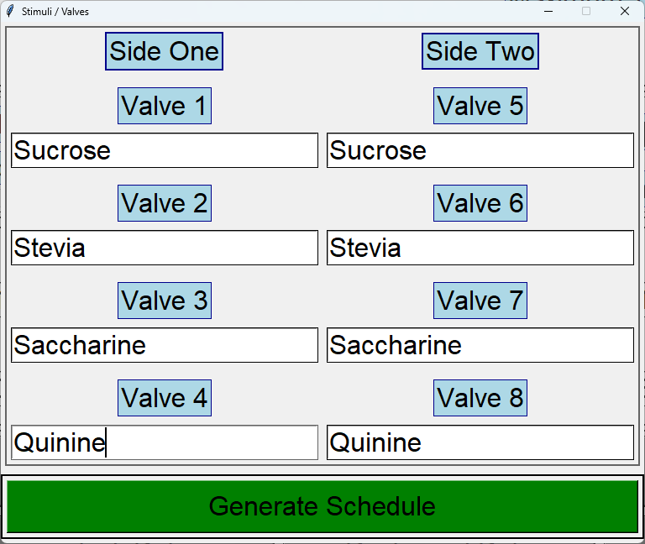

Figure 13

1. Clearly label two (one for each lick spout) 50 ml beakers using lab tape with ‘1’ and ‘2’ for measuring the outputs of the spouts during testing to prevent any confusion regarding which beaker contains which measurement. These values will be matched with the numbers taped on the breadboard (depicted in Figure 14) during testing.

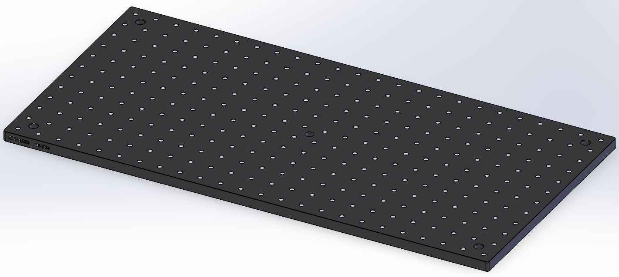

Figure 14

1. The spout delivery lines, as depicted in Figure 11, are currently empty. These lines must be completely filled prior to conducting valve calibration or running any experiments. To achieve this, we will pressurize the system to push the stimuli all the way to the tips of the lines.

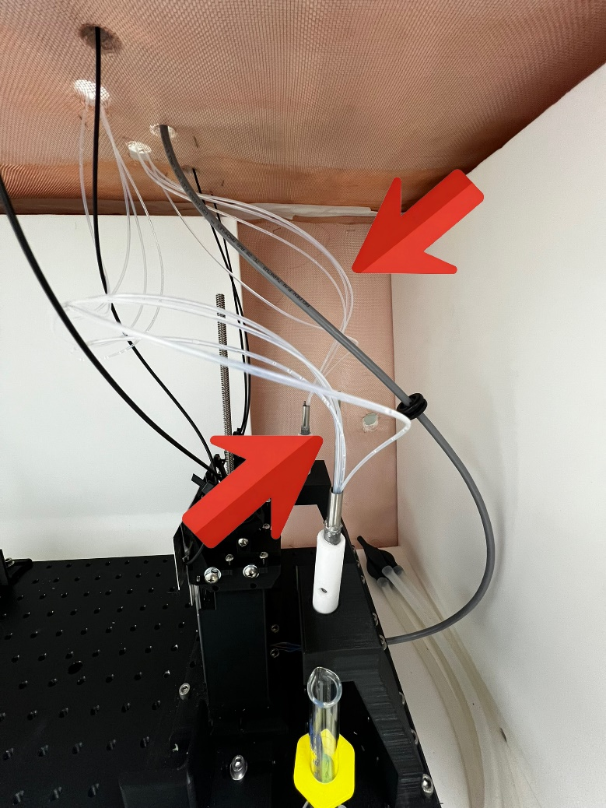

Figure 15

**Preparing the valves**

1. To begin this process, first open the ‘Valve Control’ window. This can be accessed by clicking the *‘Valve Control’* button in the main window. (Figure 12)

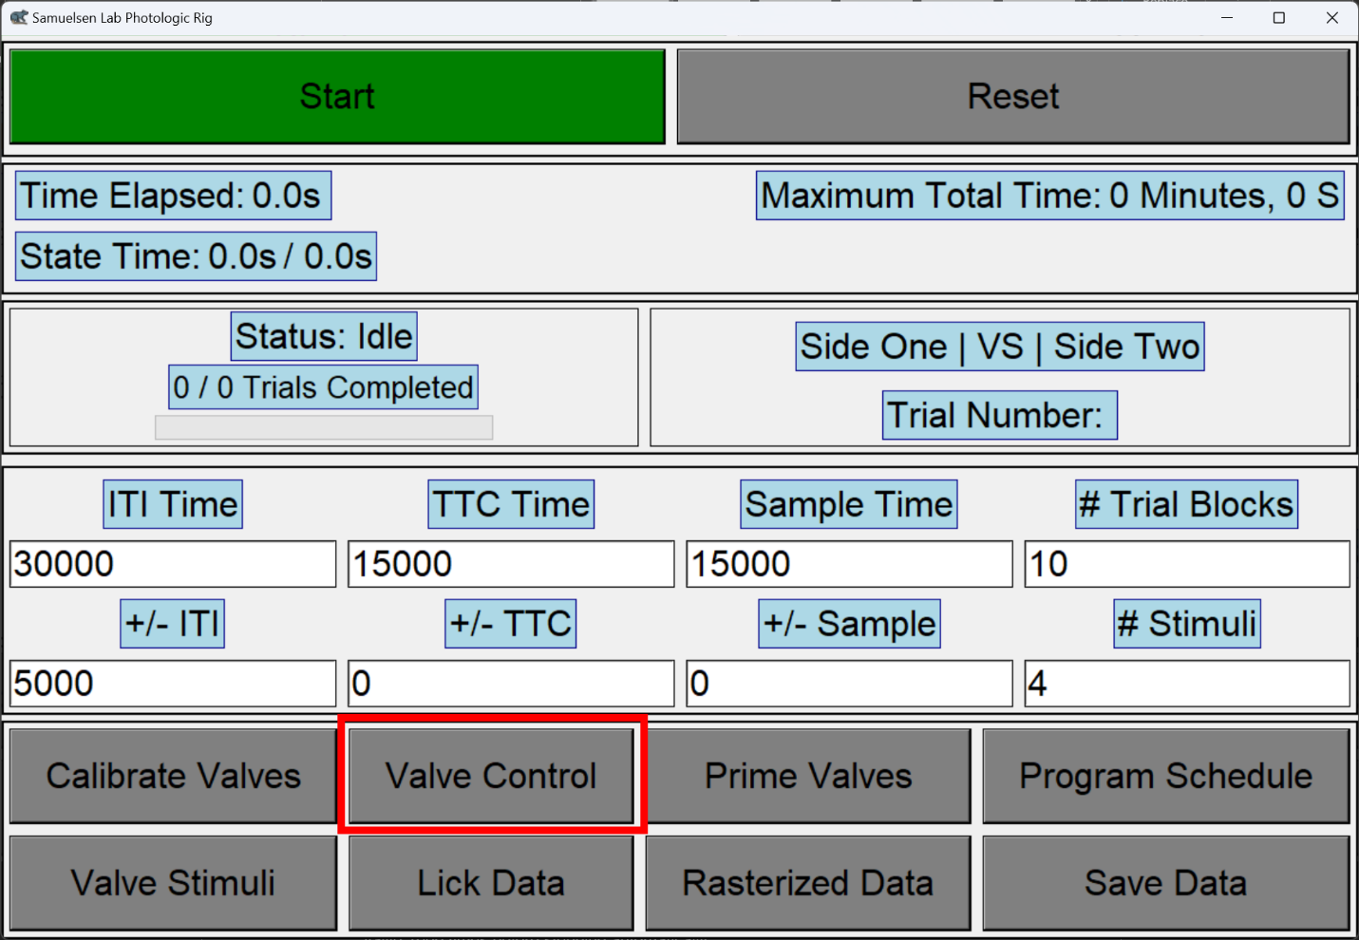

Figure 16

1. Insert the spout assemblies (Figure 16) directly into the beakers previously mentioned so that all dispensed liquid for the next steps is caught. Match the number from each beaker with the correct spout side.

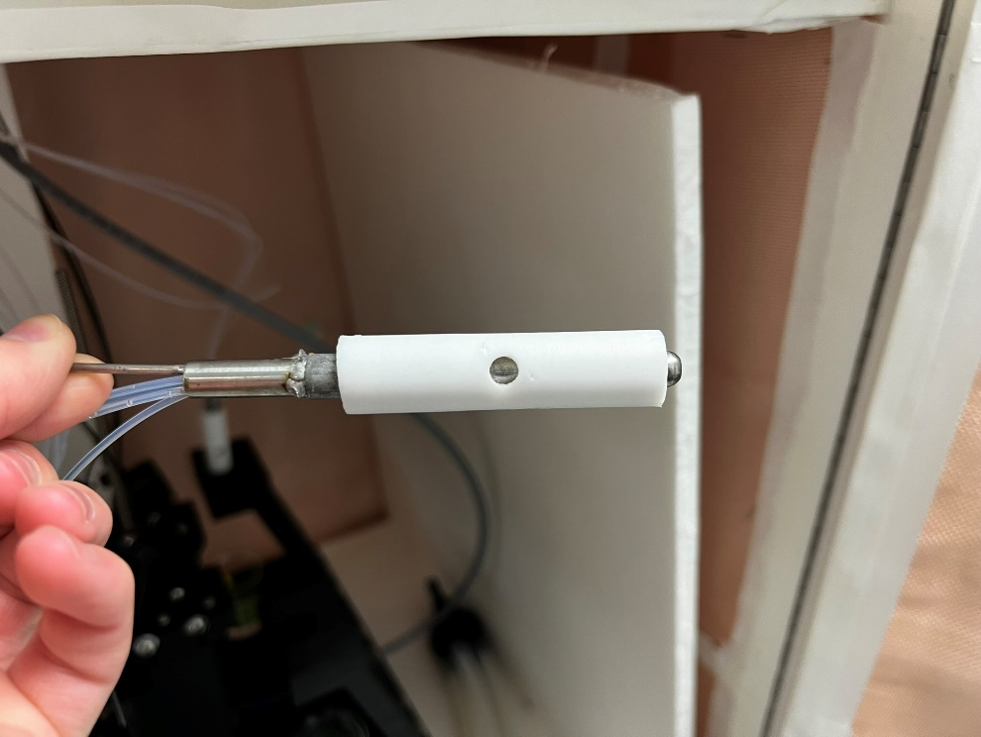

Figure 17

1. Refer to step 35 (e – f) for directions on how to prepare the stimulus columns for priming. Stimulus columns are pictured below in Figure 16.

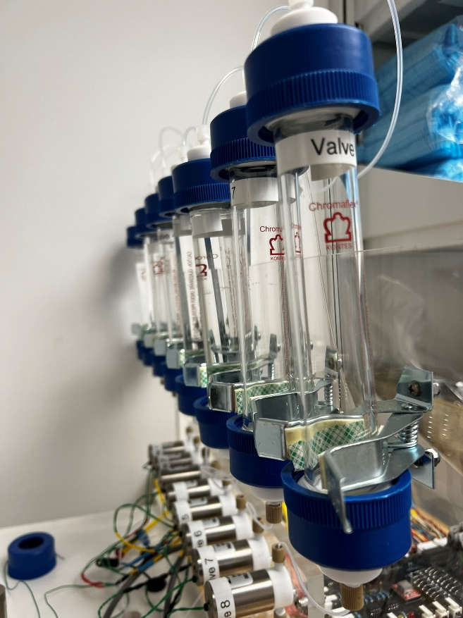

Figure 18

1. After securing the cylinder tops and pressurizing the system as outlined in step 35 (e-f), proceed to open the necessary valves for your experiment. For instance, if your experiment involves two unique stimuli (such as sucrose and water), open valves 1, 2, 5, and 6. Open each valve **one at a time**; this helps to easily check when a delivery tube is ready for use. An example image is shown below in Figure 17.
2. Upon opening a valve, monitor the corresponding delivery tubes inside the cabinet. If this valve is dispensing liquid in the beaker, press the button for the valve previously opened once again in the 'Valve Control' window to close this valve.
3. Once all valves have been prepared by pushing liquid all the way through to the ends of the tubes, ensure all valves are closed. All buttons in the ‘Valve Control’ window should be red except for the motor control button, which should remain green. DO NOT REMOVE THE CYLINDER TOPS AT THIS STAGE.

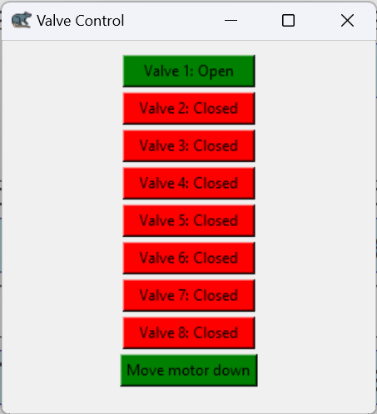

Figure 19

1. Turn the pressure valve off on the tank at the far end of the room by twisting clockwise if gripped as shown in Figure 18. DO NOT REMOVE THE CYLINDER TOPS AT THIS STAGE.

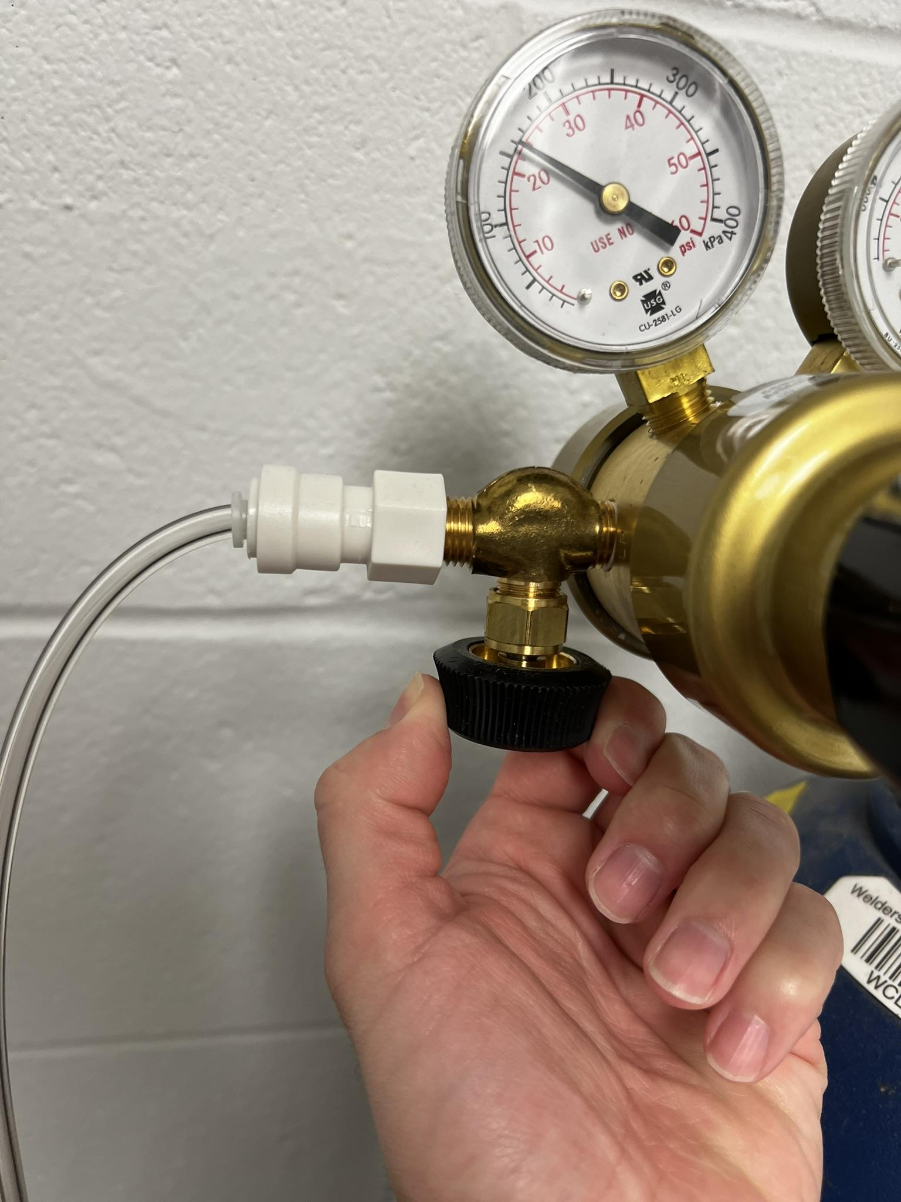

Figure 20

1. In the 'Valve Control' window, it's necessary to release the remaining pressure in the cylinders before removing the cylinder tops. To do this safely without releasing more stimulus than necessary:
   1. Identify Empty Cylinders: Determine which (if any) cylinders contain no stimulus. These are preferred for pressure release to avoid unnecessary discharge of liquid.
   2. Identify Valves to Open: If you are utilizing all 8 valves for this experiment, open any 4 valves of your choice.
   3. Operate Valves: Click the buttons corresponding to the selected valves to open them.
   4. Time Duration: Leave the valves open for approximately 15-20 seconds to ensure all residual pressure is released.
   5. Monitor and Close: After the time has elapsed and pressure has been released, close all valves by pressing all currently green buttons in the ‘Valve Control’ window until they are once again red.
   6. Now it is safe to unscrew and remove the tops from all cylinders to continue the experiment.
2. Empty all liquid from the beakers into the sink. Rinse each beaker under tap water. Shake out any remaining pools of liquid from the bottom of each beaker to ensure they are thoroughly drained.
3. Refill each stimulus column in use to the top at the lip just below where the threads end as in Figure 19. Refer to the note left in step 7 for which stimuli are in which positions.

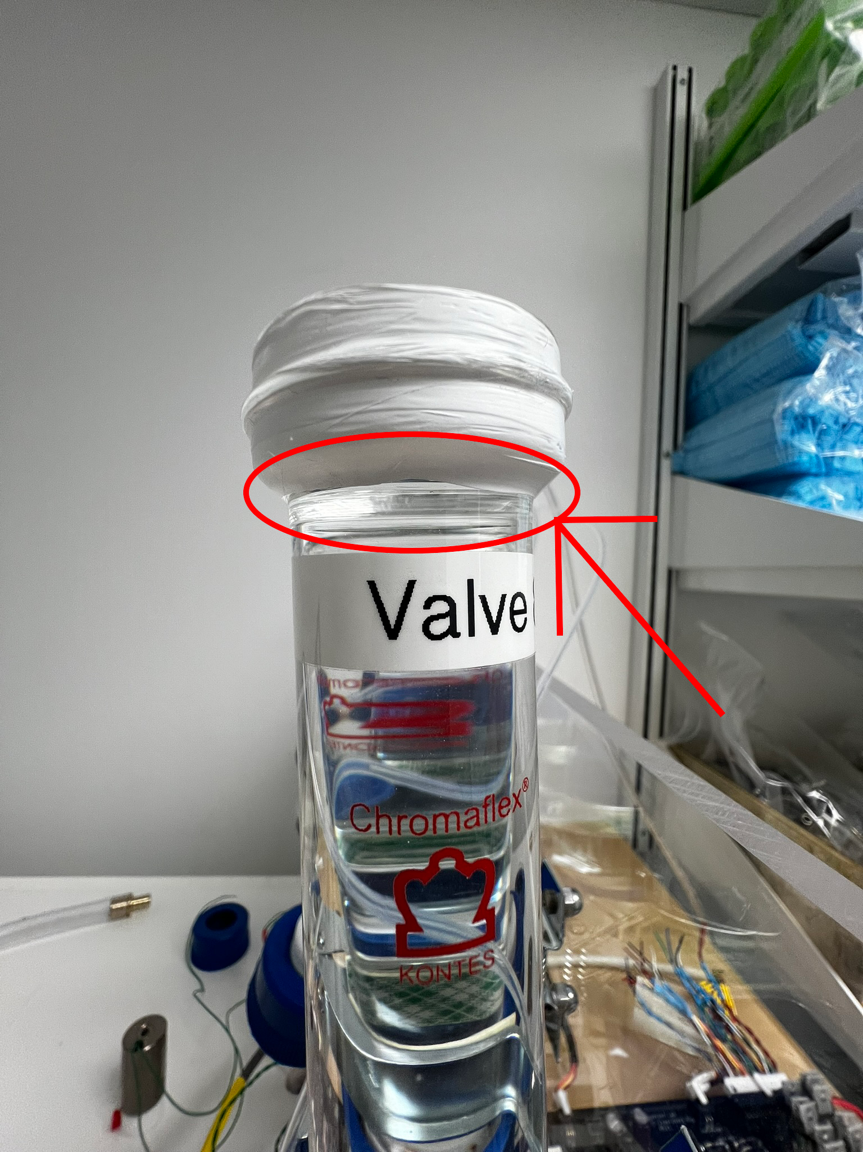

Figure 21

**Valve Calibration:**

**NOTE:** If at any point you wish to cancel the calibration of the spouts, you must wait for the current pair to finish, then on the data collection popup windows, click ‘Cancel’ and in the ‘Input Canceled’ window that appears, click NO. Repeat this for side 2. Then on the ‘Are you Ready to Continue’ popup, click no. Testing will then be canceled.

If you then wish to begin a calibration again, you must reset the application by clicking ‘Reset’ in the main application window. You can then initiate the process again.

1. Calibrate the valves to ensure that each dispenses the desired amount of microliters of the stimuli with every opening.
   1. First, weigh each beaker **without any liquid** using the blue VWR scale in the surgery room and record the value in grams. Record these values for later input, making sure to clearly mark which beaker is for which spout side.
   2. 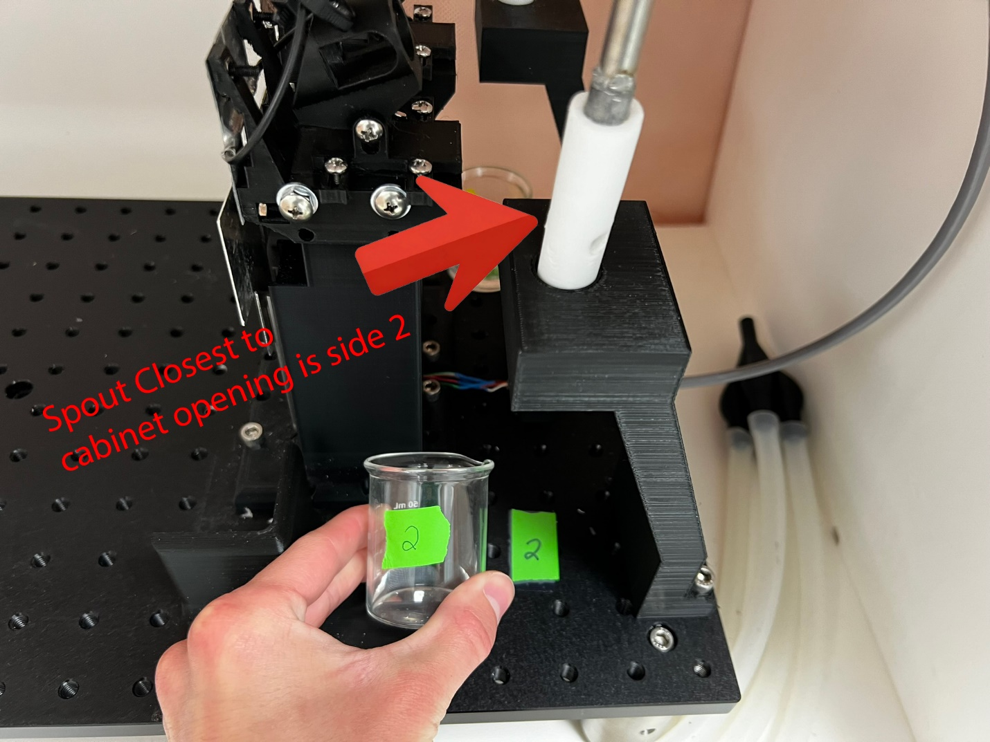Insert the spout assemblies directly into the labelled beakers, matching the number on the beaker with the spout by referring to the numbers on the breadboard as shown in Figure 22 so that all dispensed liquid is caught.

Figure 22

* 1. Click the *‘Calibrate Valves’* button in the main application window (Figure 23).

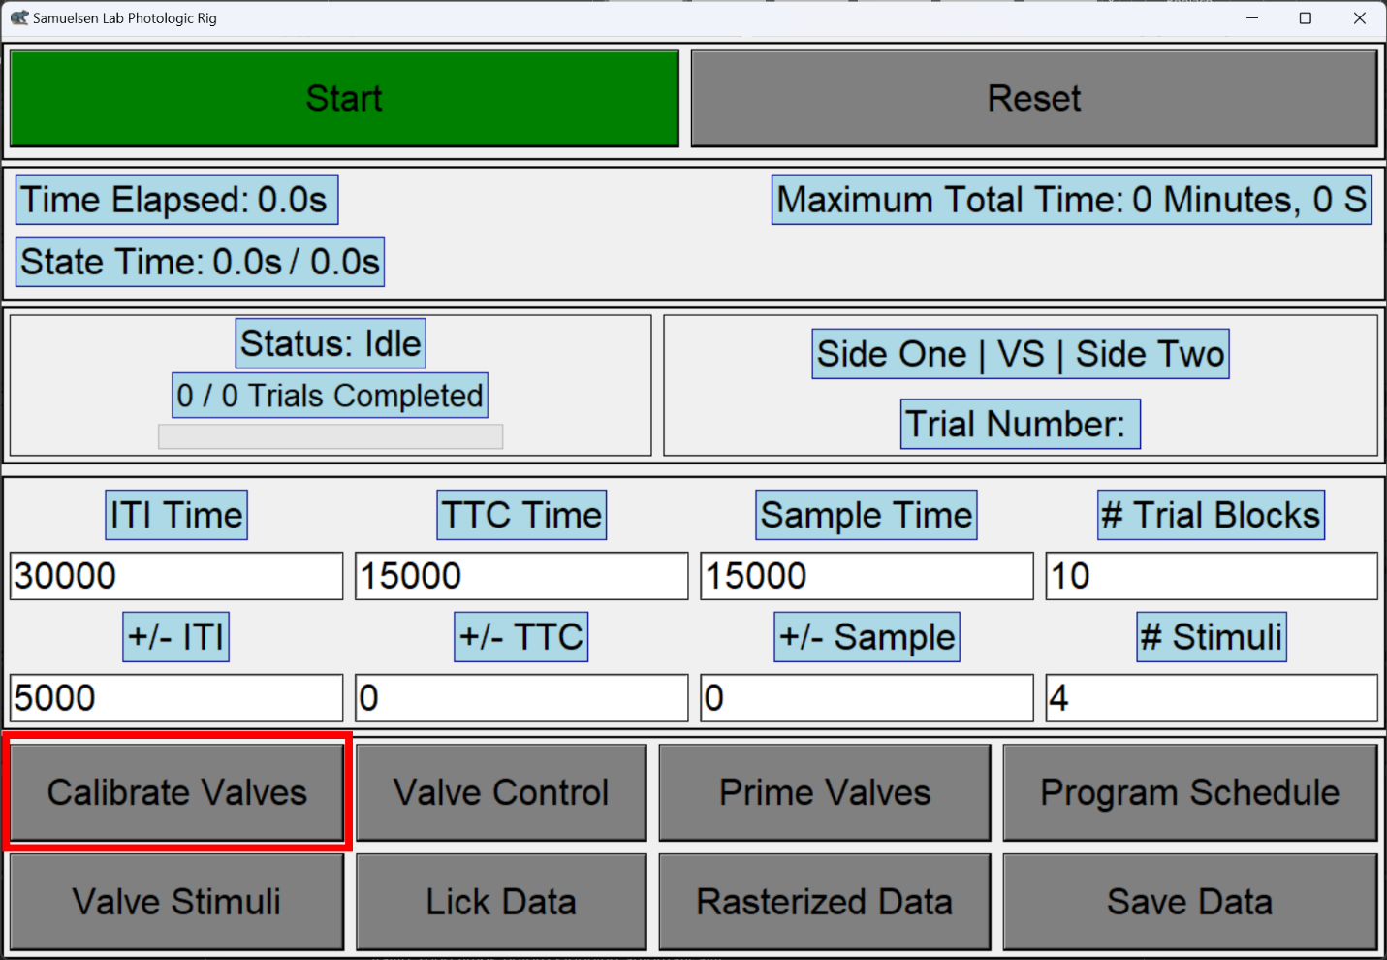

Figure 23

* 1. Enter the number of valves to be used (calculated as the number of stimuli times two), the desired number of stimuli dispensed per lick (in microliters), and then press the green *‘Start Testing’* button (Figure 24).

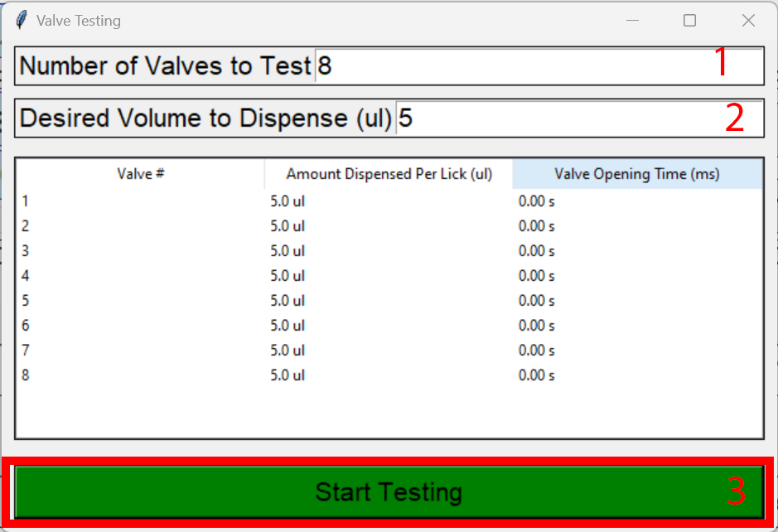

Figure 24

* 1. Now enter the weight in grams of each **EMPTY** beaker for side 1 and side 2 (obtained in step a) to two decimal places as prompted by the software, e.g. 29.03 cm³, after hitting ‘OK’ in the side 2 volume prompt, the testing will begin.
  2. Measure the beaker for each side on the blue VWR scale to two decimal places.
  3. After the initial testing cycle, the first popup window will prompt you to enter the volume for valve 1 (side 1). Enter the weight in grams obtained from the VWR scale for this valve. The second popup will prompt you to enter the volume for valve 5, which is the first valve on side 2. Enter the corresponding value. Any subsequent testing cycles will follow a similar pattern: the next cycle will prompt you to enter values for valve 2 (side 1) and valve 6 (side 2), and so on, continuing in this sequence for all valves.
  4. After both values have been entered, another popup will display asking if you would like to continue. First, place the beakers back under the corresponding test stand, then press *‘Yes’* on the popup.
  5. Steps e-f will automatically repeat until the number of valves entered in step 1 of Figure 24 have been tested.

1. After a calibration cycle has been completed, the table inside of the ‘Valve Testing’ window will be updated to contain the ‘Amount Dispensed Per Lick’ and ‘Valve Opening Time’ values. Check these values. If any of the ‘Amount Dispensed Per Lick’ values deviate significantly from the expected (generally 5ul) output, run the calibration cycle (step 20 b-i) once again to ensure equal delivery across different valves.
2. Once the valves have been calibrated and the delivery lines have been prepared, you can now move the spouts into the spout clamping assembly (Figure 25) on the delivery mount stand. Slide the spouts into the housings until the stainless-steel spouts are in direct contact with the spout faceplates (Figure 29).
   1. Ensure that the vacuum tube holes of the spout on BOTH sides are accessible through the openings in the spout clamping assembly as shown in Figure 26 and Figure 27 when in direct contact with the spout faceplates. If the hole in the stainless-steel spout does not line up perfectly with the sides of the spout as in Figure 29, see adjustment procedure in step 23b.

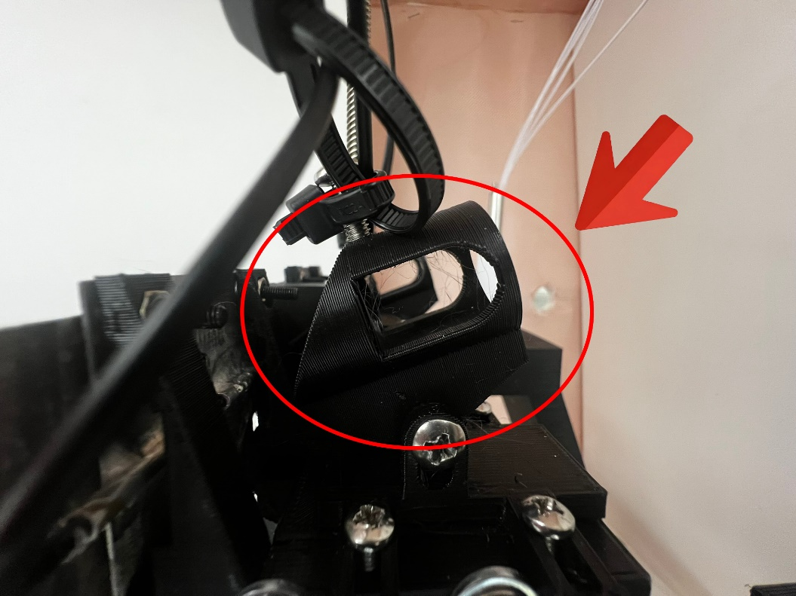

Figure 25

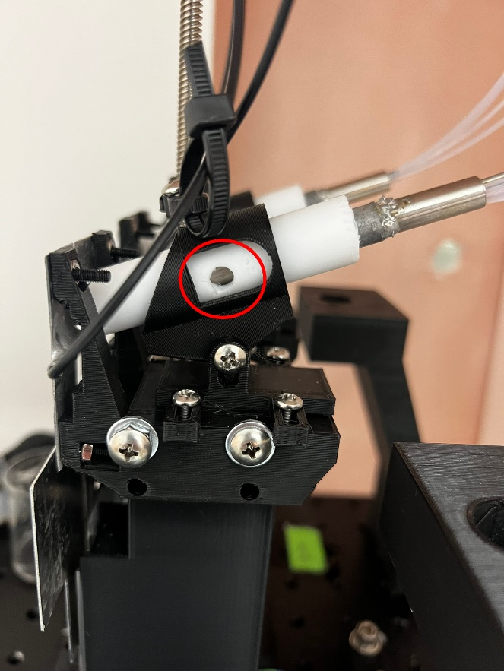

Figure 26

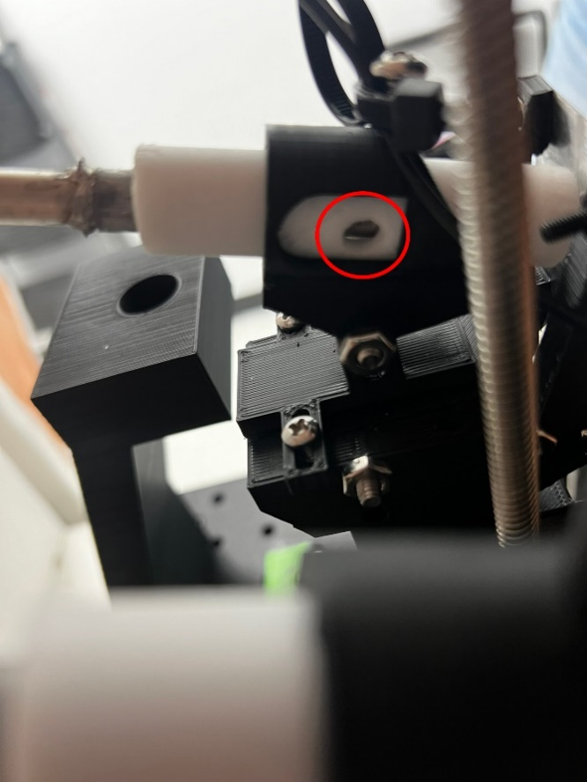

Figure 27

* 1. Turn the top spout adjustment screw with a Phillips head screwdriver as in Figure 28 so that the spout can no longer move forwards and backwards in the spout housing assembly. You may need to push the screwdriver quite hard downwards into the slot and then turn to avoid stripping out the screw.

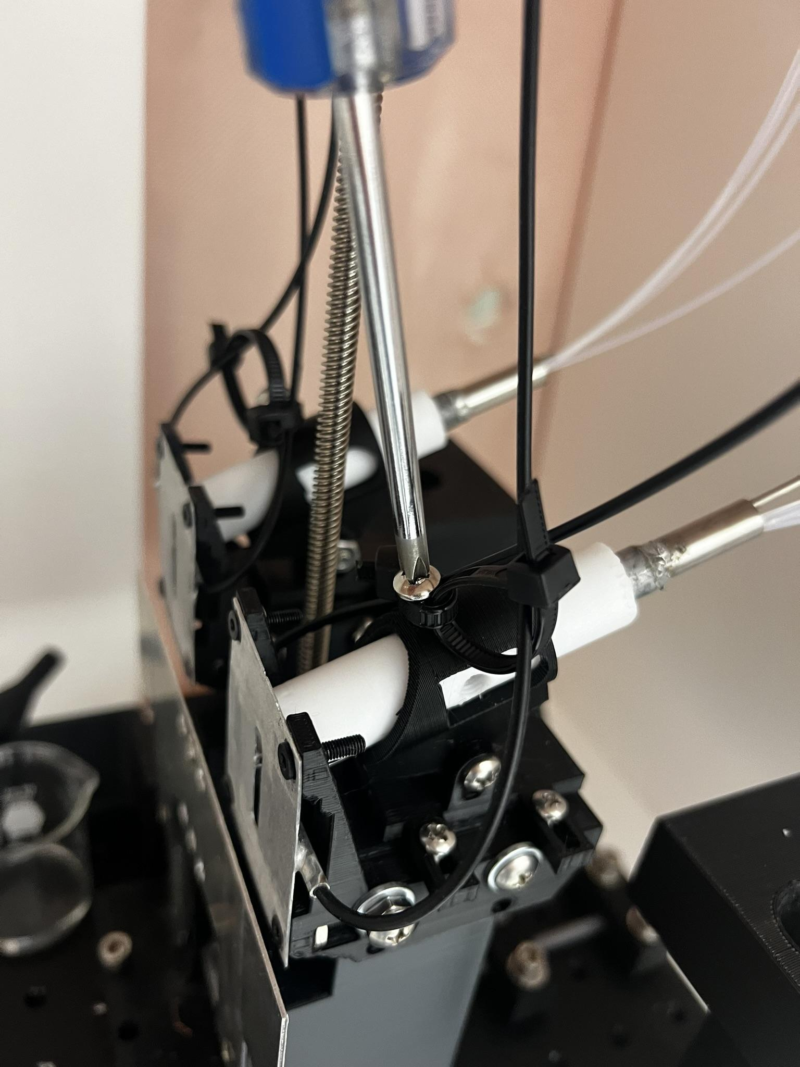

Figure 28

1. Ensure that the angle adjustment has not moved, and each spout sits at the top of the spout faceplate, with the sides of the spout hole aligned with the sides of the faceplate lick slot as shown in Figure 29.
   1. If the angle adjustment or height adjustment has been altered somehow, you can adjust these using the adjustment screw attaching the clamping assembly to the delivery mount as shown in Figure 31. You can now adjust the angle or adjust the height of the clamping assembly up and down.
   2. If the side-to-side adjustment has come out of alignment, pushing the spout to the left or to the right of the faceplate opening, you can adjust the side-to-side bracket by turning the 3 securing screws shown in Figure 30 counterclockwise. You may have to press the screwdriver down hard into the slot to avoid stripping them out. Then placing your fingers on the back two screw slots on the side-to-side bracket as in Figure 32, you can move the bracket left or right to properly align it with the faceplate as shown in Figure 29. Pressing firmly helps the bracket slide more smoothly.

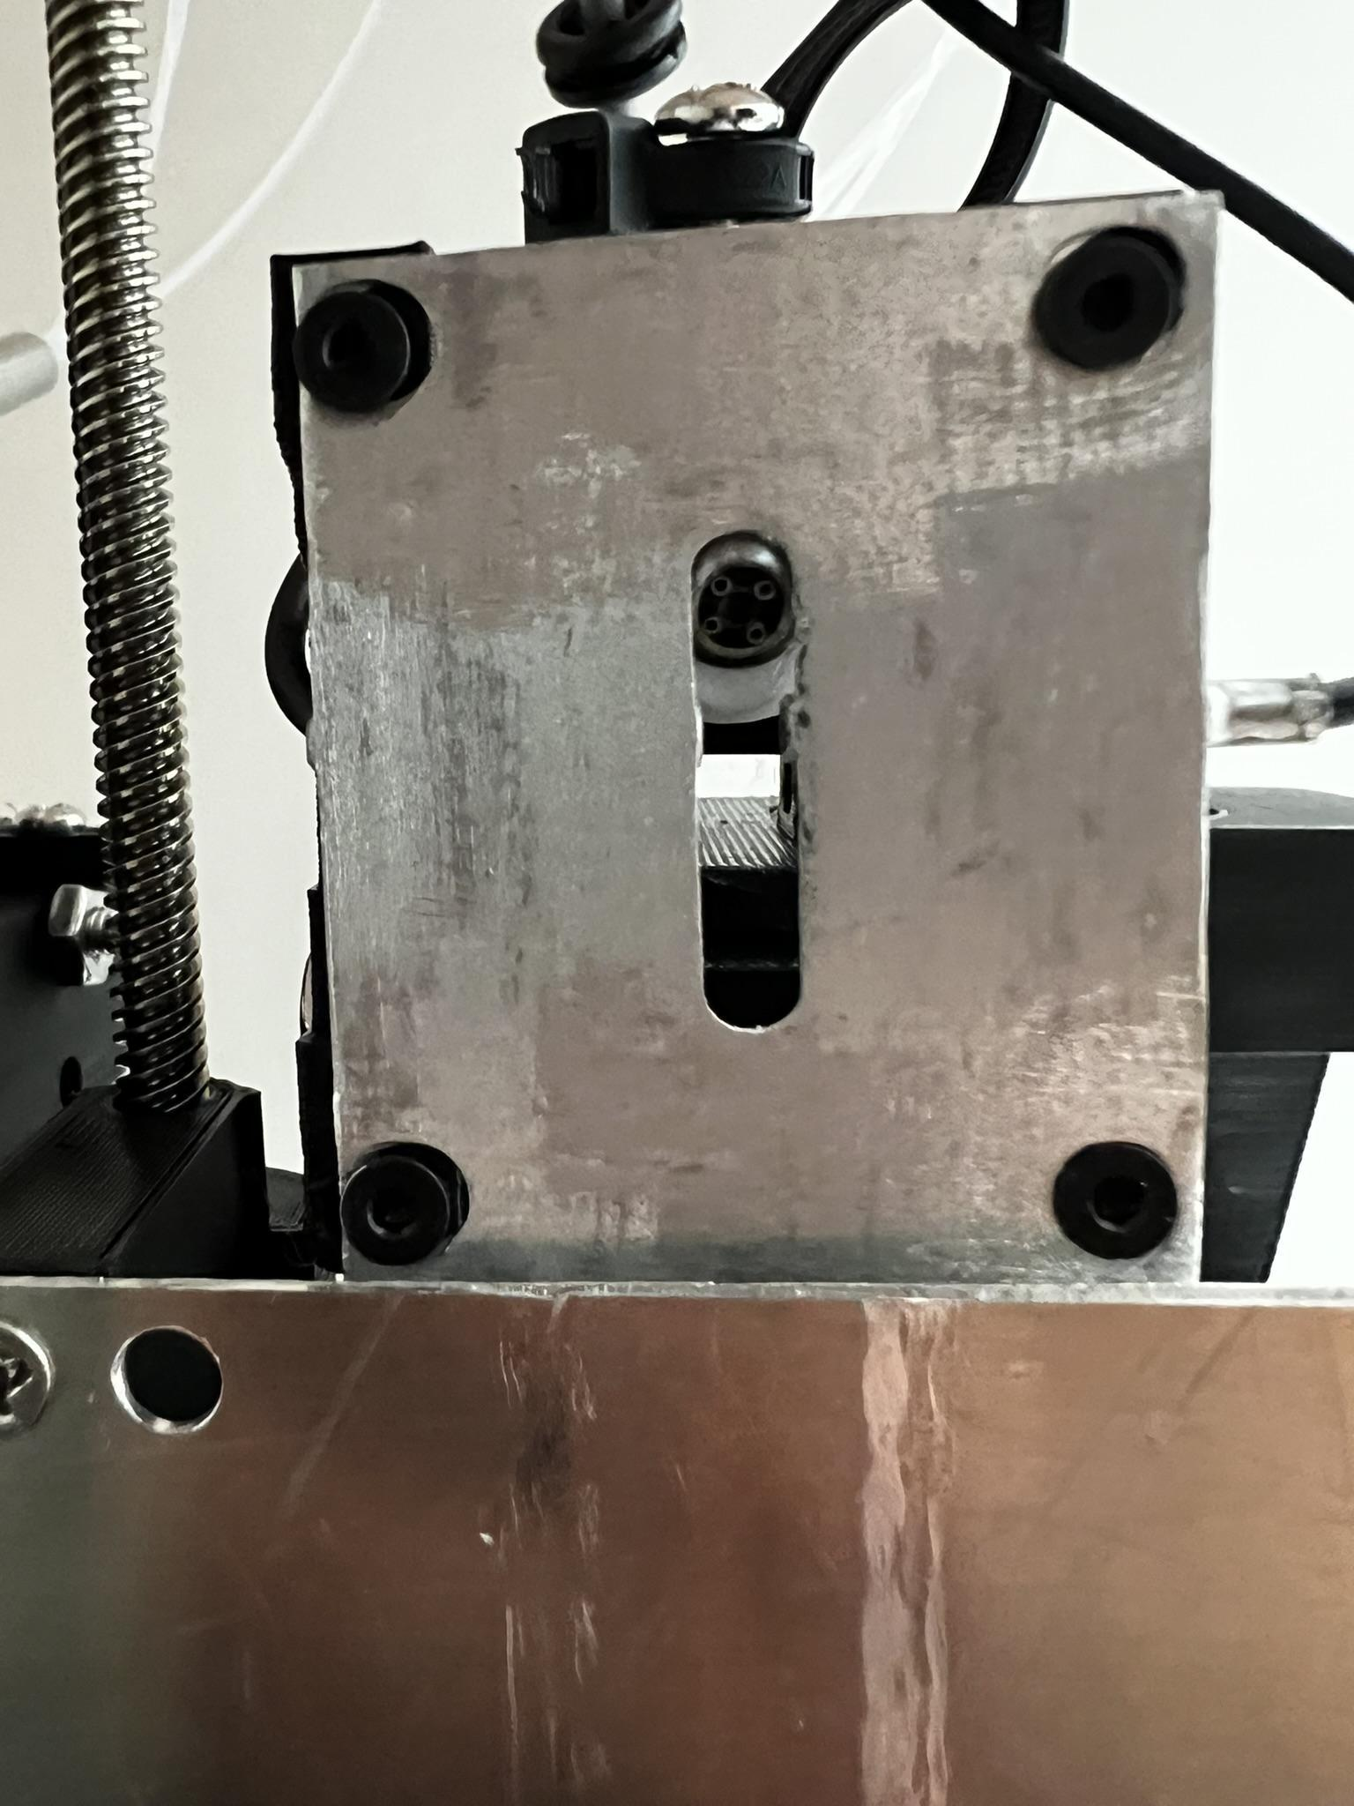

Figure 29

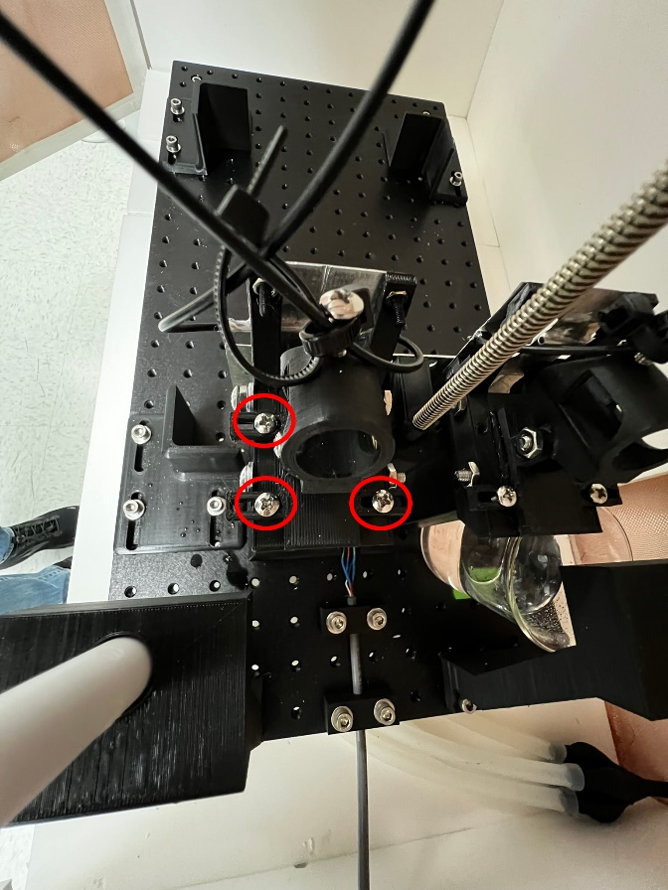

Figure 30

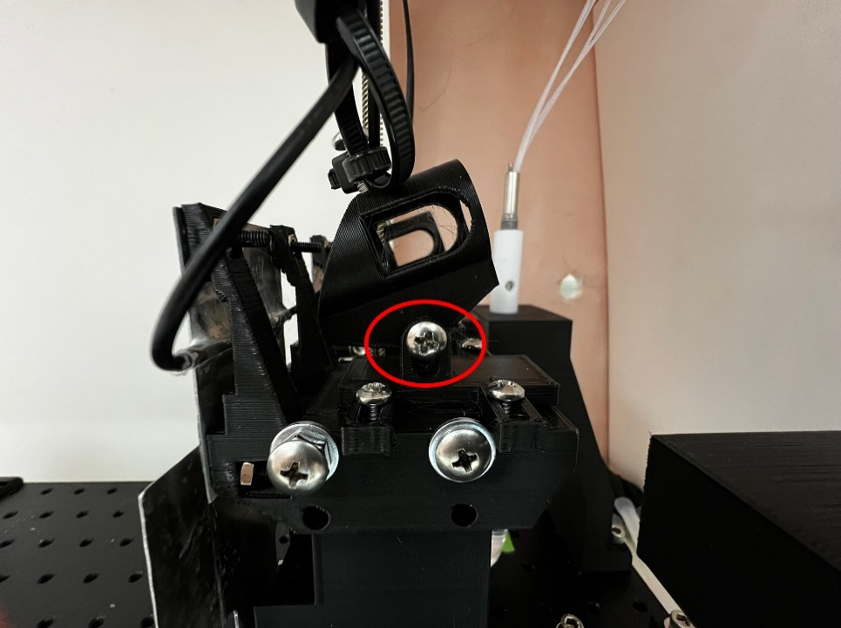

Figure 31

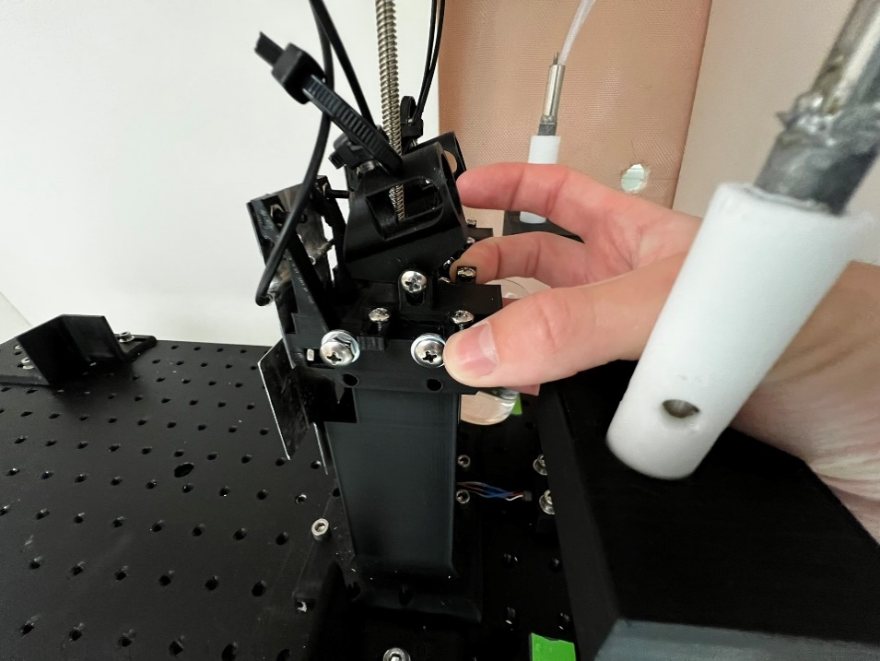

Figure 32

1. Locate the beige vacuum fitting screw bag. It is on top of the experiment cabinet and is labelled ‘vacuum fitting screws’. Screw one of these into each spout vacuum hole. Be careful screwing in the fittings, the Teflon is very soft, and it is easy to damage the threads. Make sure that the fitting is going in straight into the hole. It should be easy to turn until it is tight. Turn the fittings clockwise until they are finger tight, then turn them counterclockwise ¼ of a turn (Figure 33 and Figure 34).

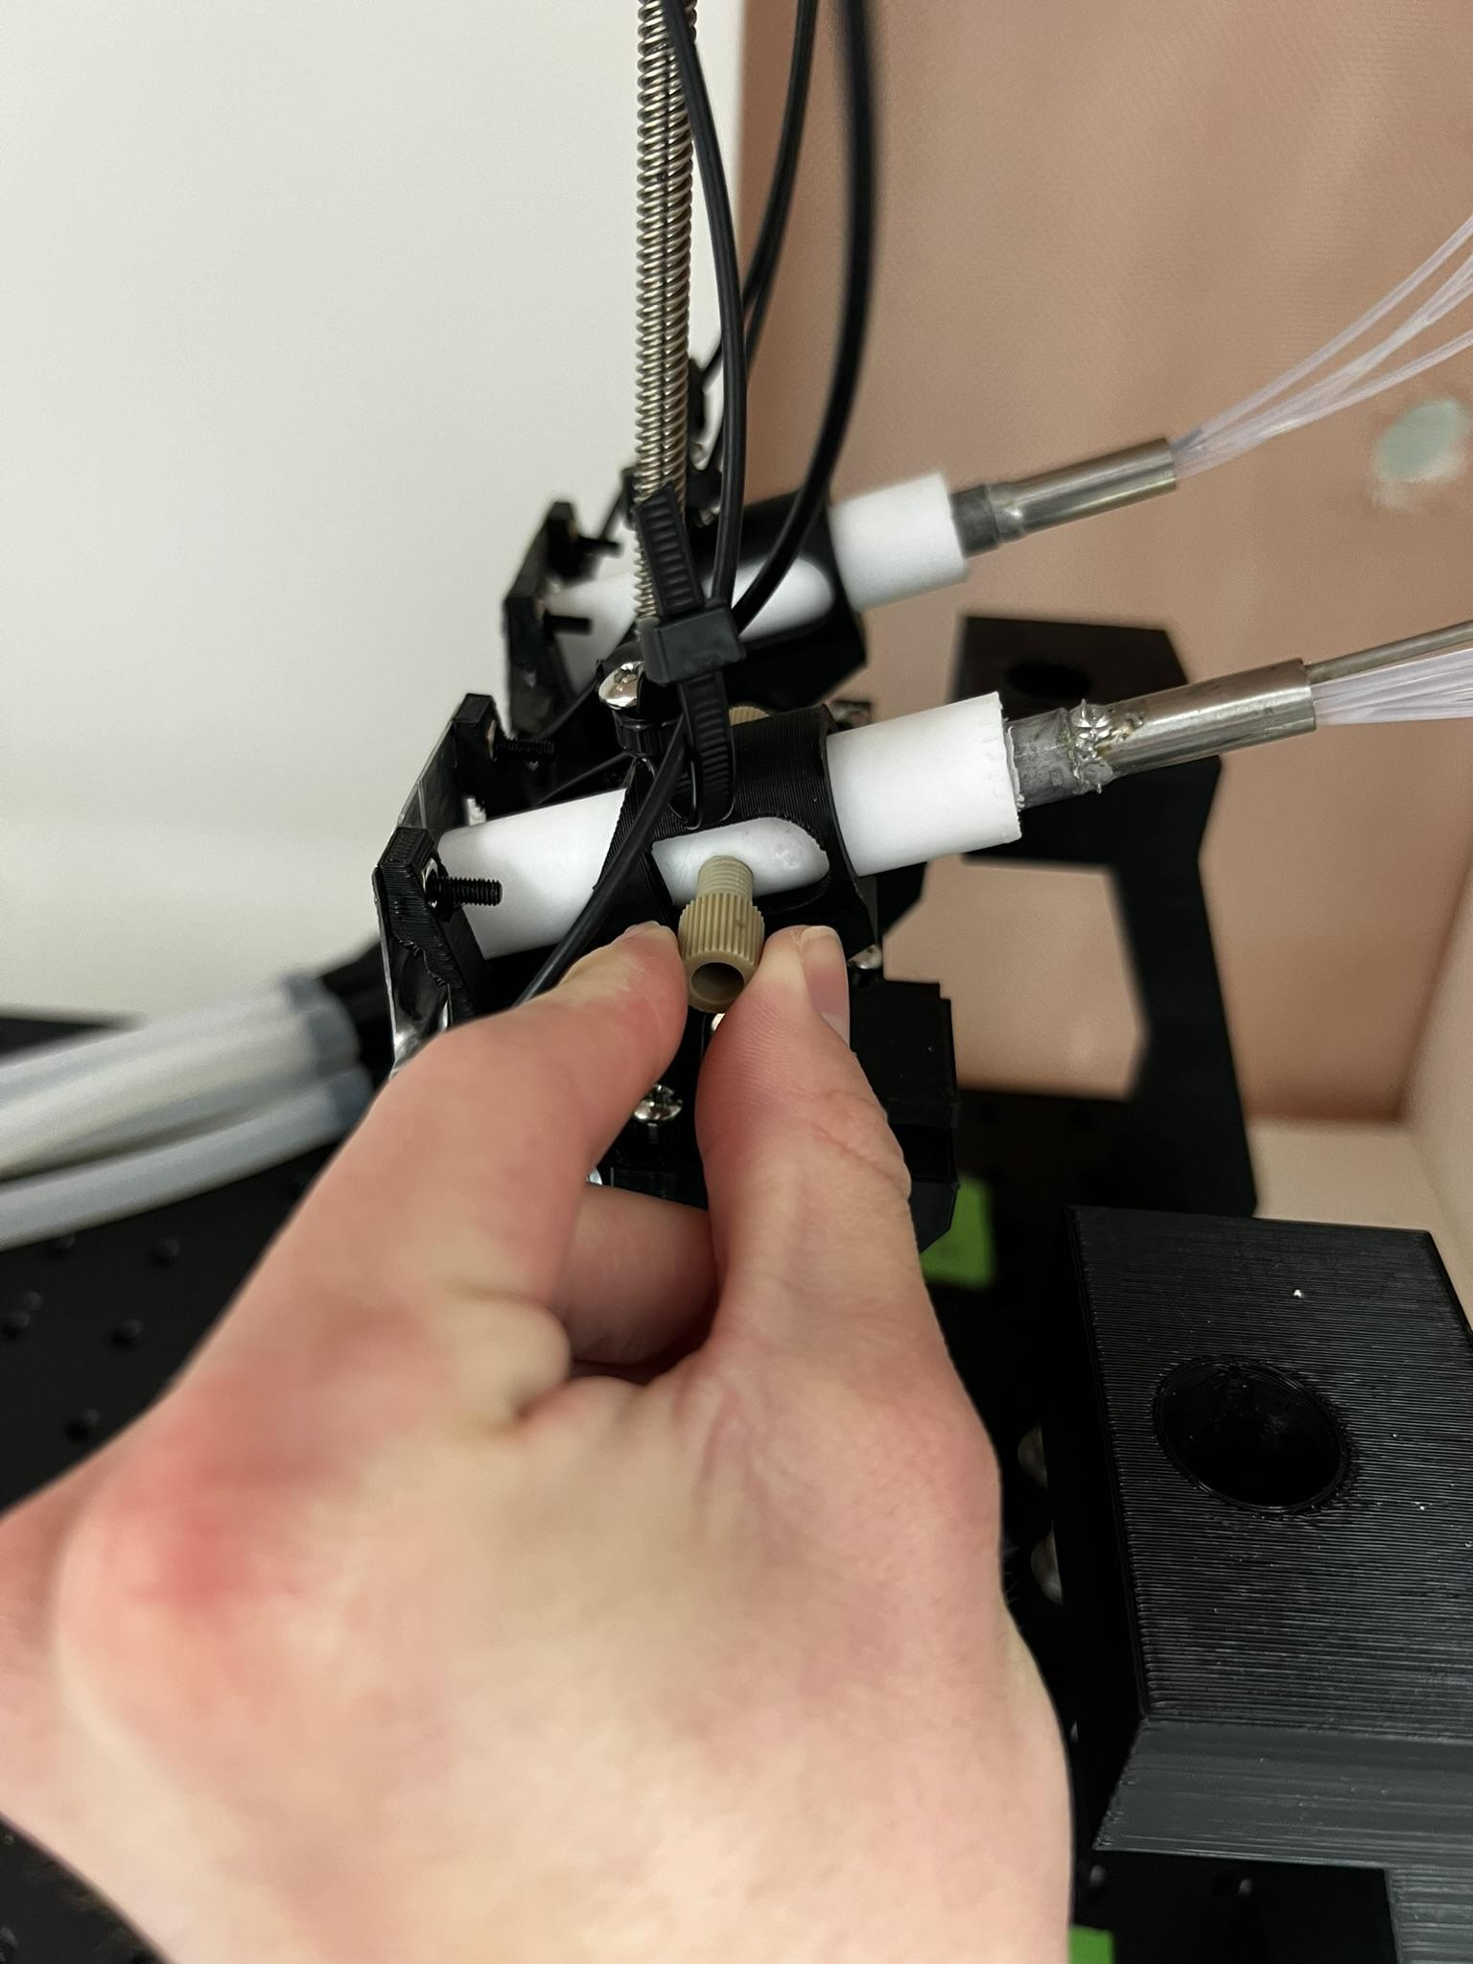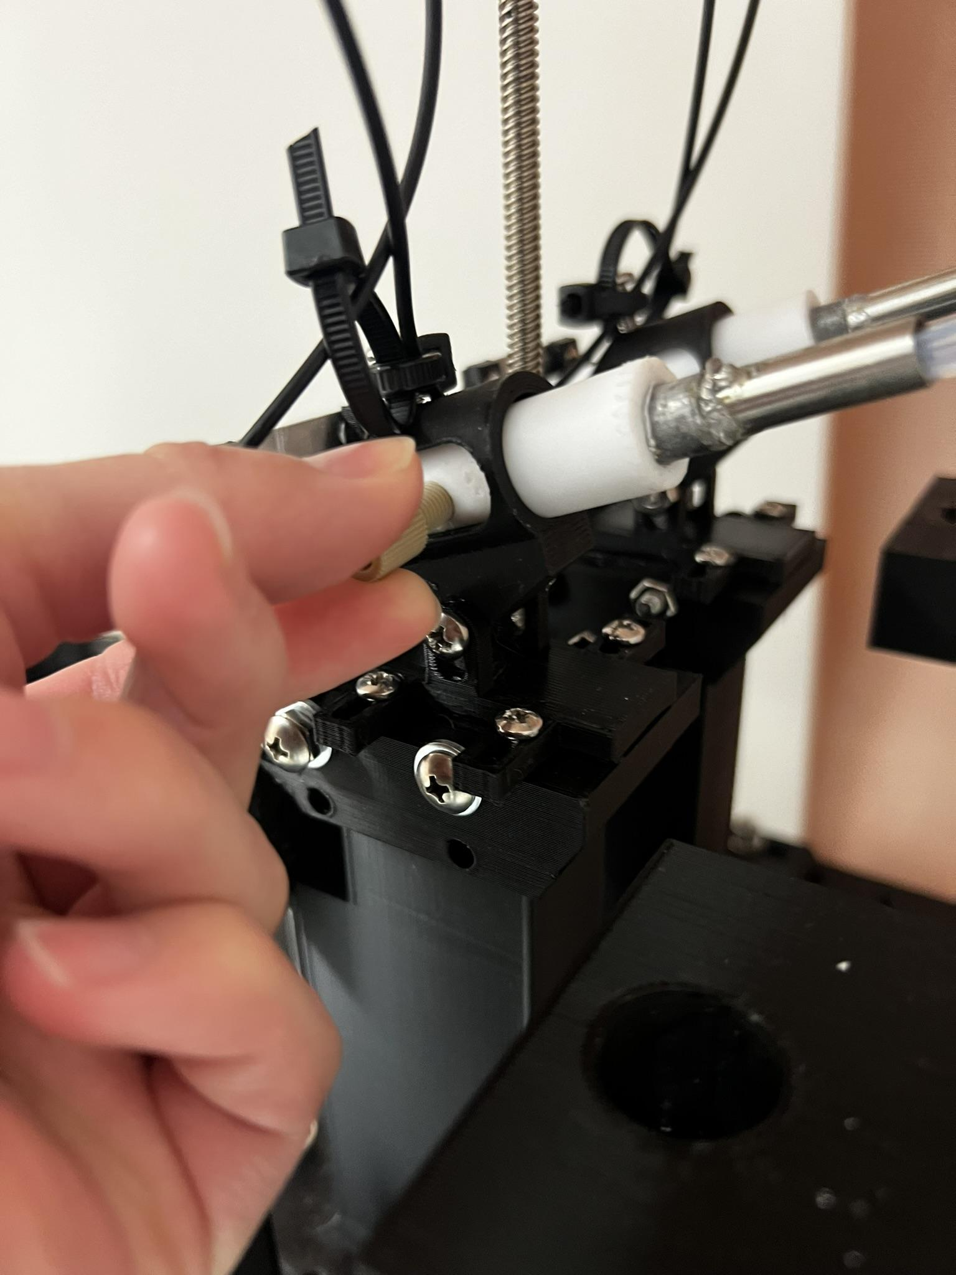

Figure 33

Figure 34

1. Carefully slide one vacuum line over each of the fittings in the spout assembly. These vacuum lines will be sitting directly under the breadboard. It does not matter which hoses attach to which fittings.

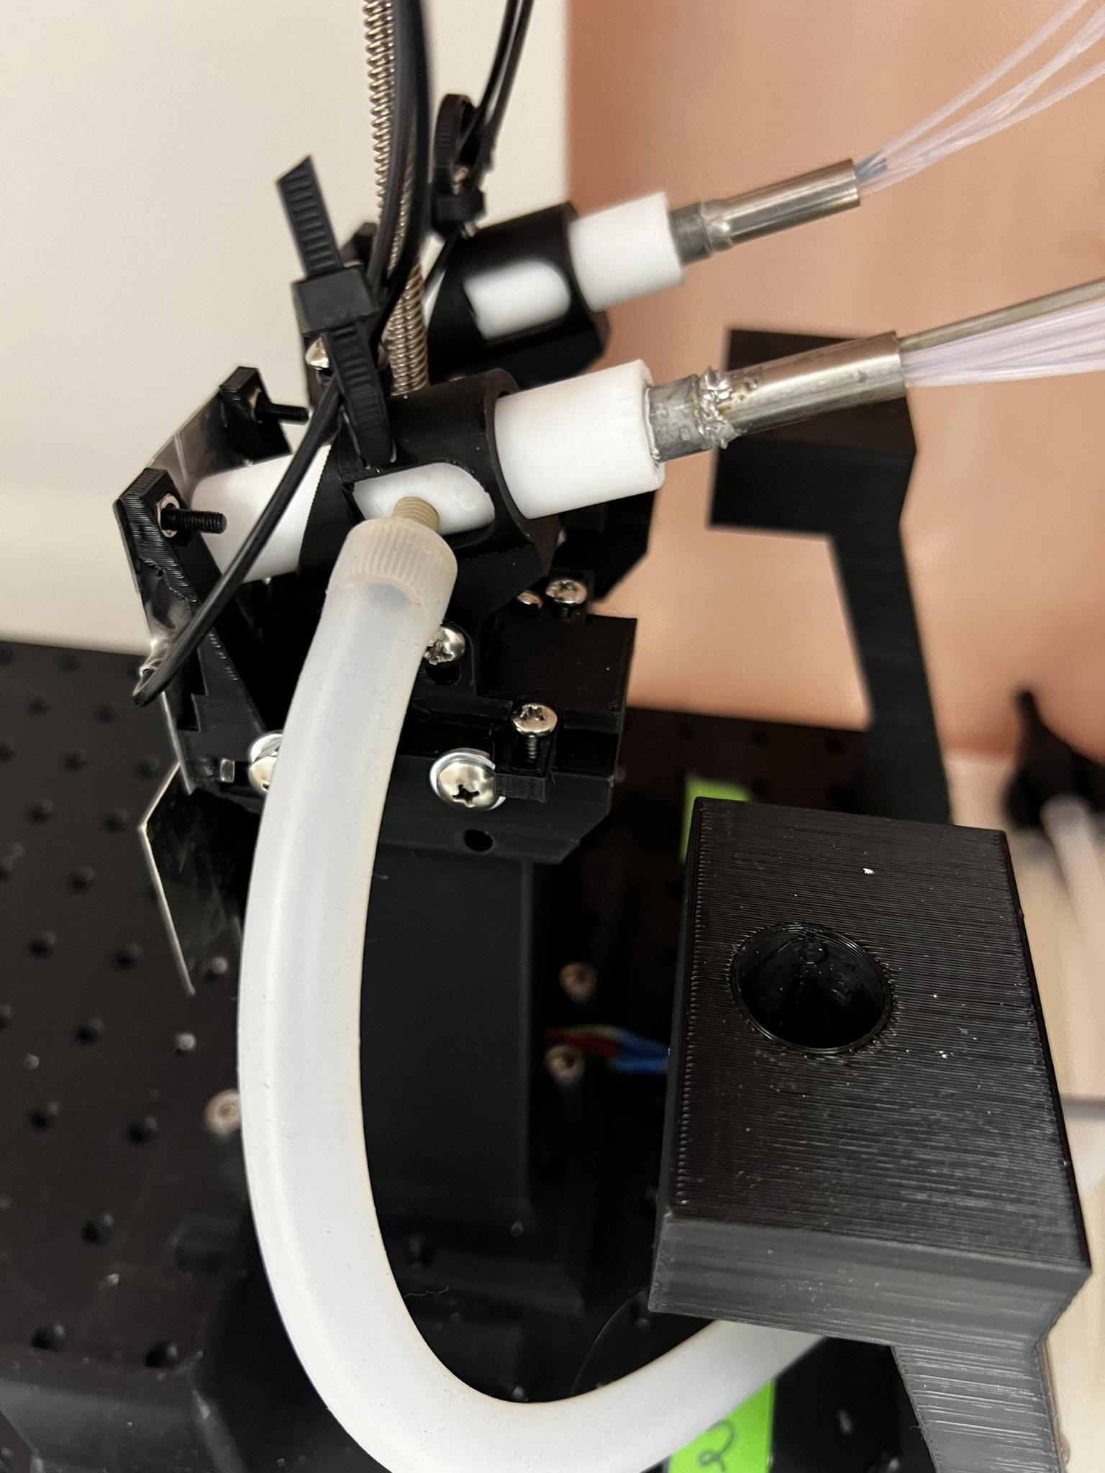

Figure 35

1. Carefully slide the cage box into position by picking the cage up with two hands, lining up the legs with the leg position locks, and pushing it down into place as shown in Figure 36 and Figure 37. The wire mesh at the bottom of the box is loose and can slide out once the box is picked up. Placing your fingers on parts of the mesh while you move the box will prevent this.
   1. It may be helpful if you press the legs furthest from the front of the cabinet (legs 1 and 4 in Figure 36) back against their corresponding position locks, and then line up the ones closest (2 and 3) to the front of the cabinet.
   2. If the cage is resisting sliding all the way down into place, gently tap each corner, moving leg 1 shown in Figure 37 clockwise around to each edge as labelled. Repeat this process until the box is sitting completely flat on all sides on the breadboard.

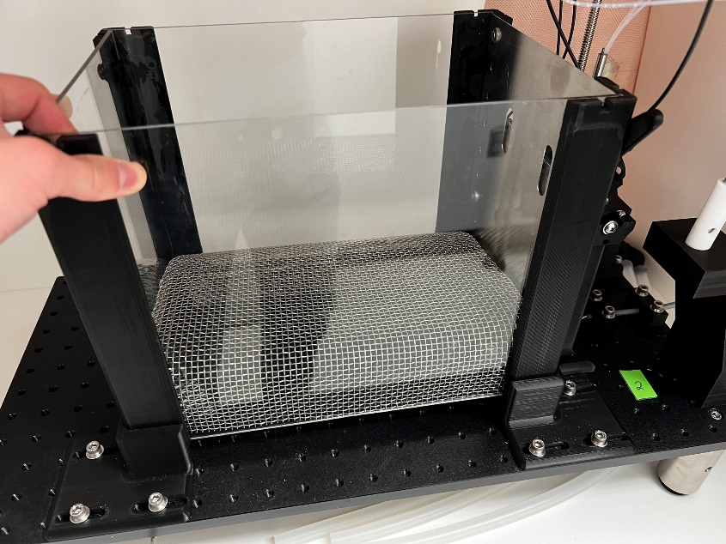

Figure 36

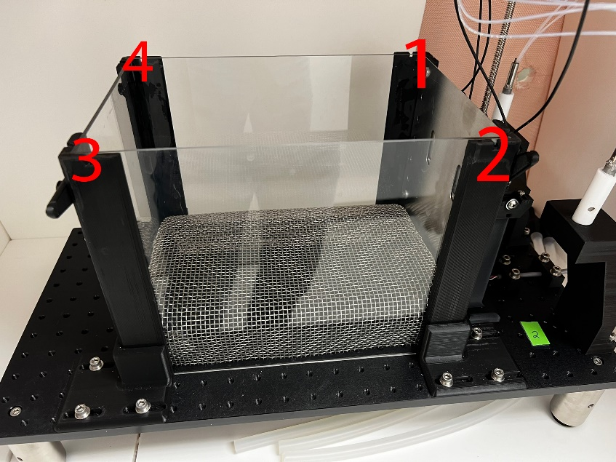

Figure 37

1. The position of the spout faceplate holes relative to the cage faceplate holes must be checked. To do this:
   1. Move door motor to the down position by clicking on ‘*Valve Control’* in the main application window (Figure 38).

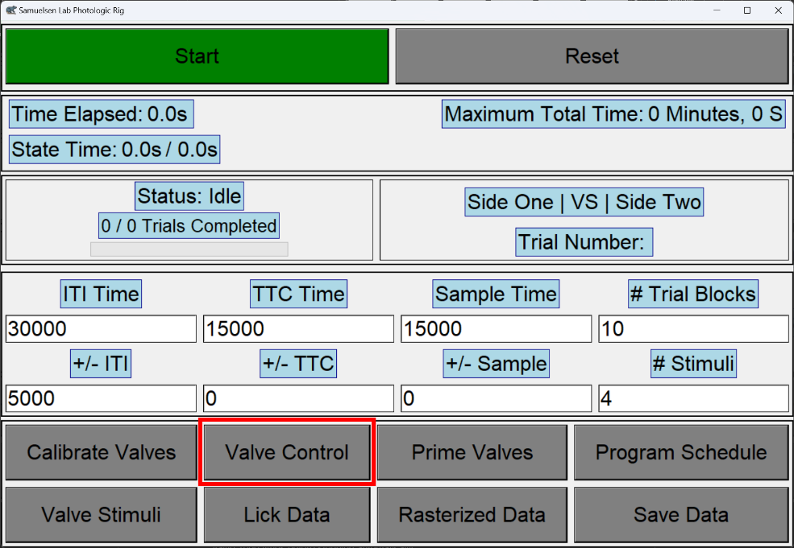

Figure 38

* 1. Click *‘Move Motor Down’* to send the command (Figure 39).

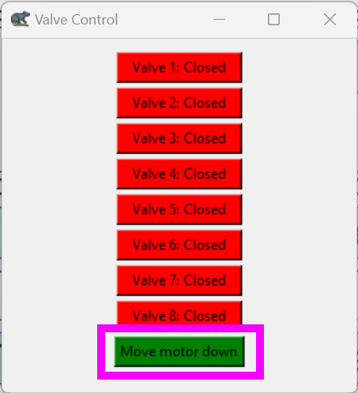

Figure 39

* 1. Check the positions of the holes. The spout faceplate holes should be centered on both sides inside of the main cage faceplate holes. An example of correct and incorrect faceplate hole positionings is shown in Figure 40.

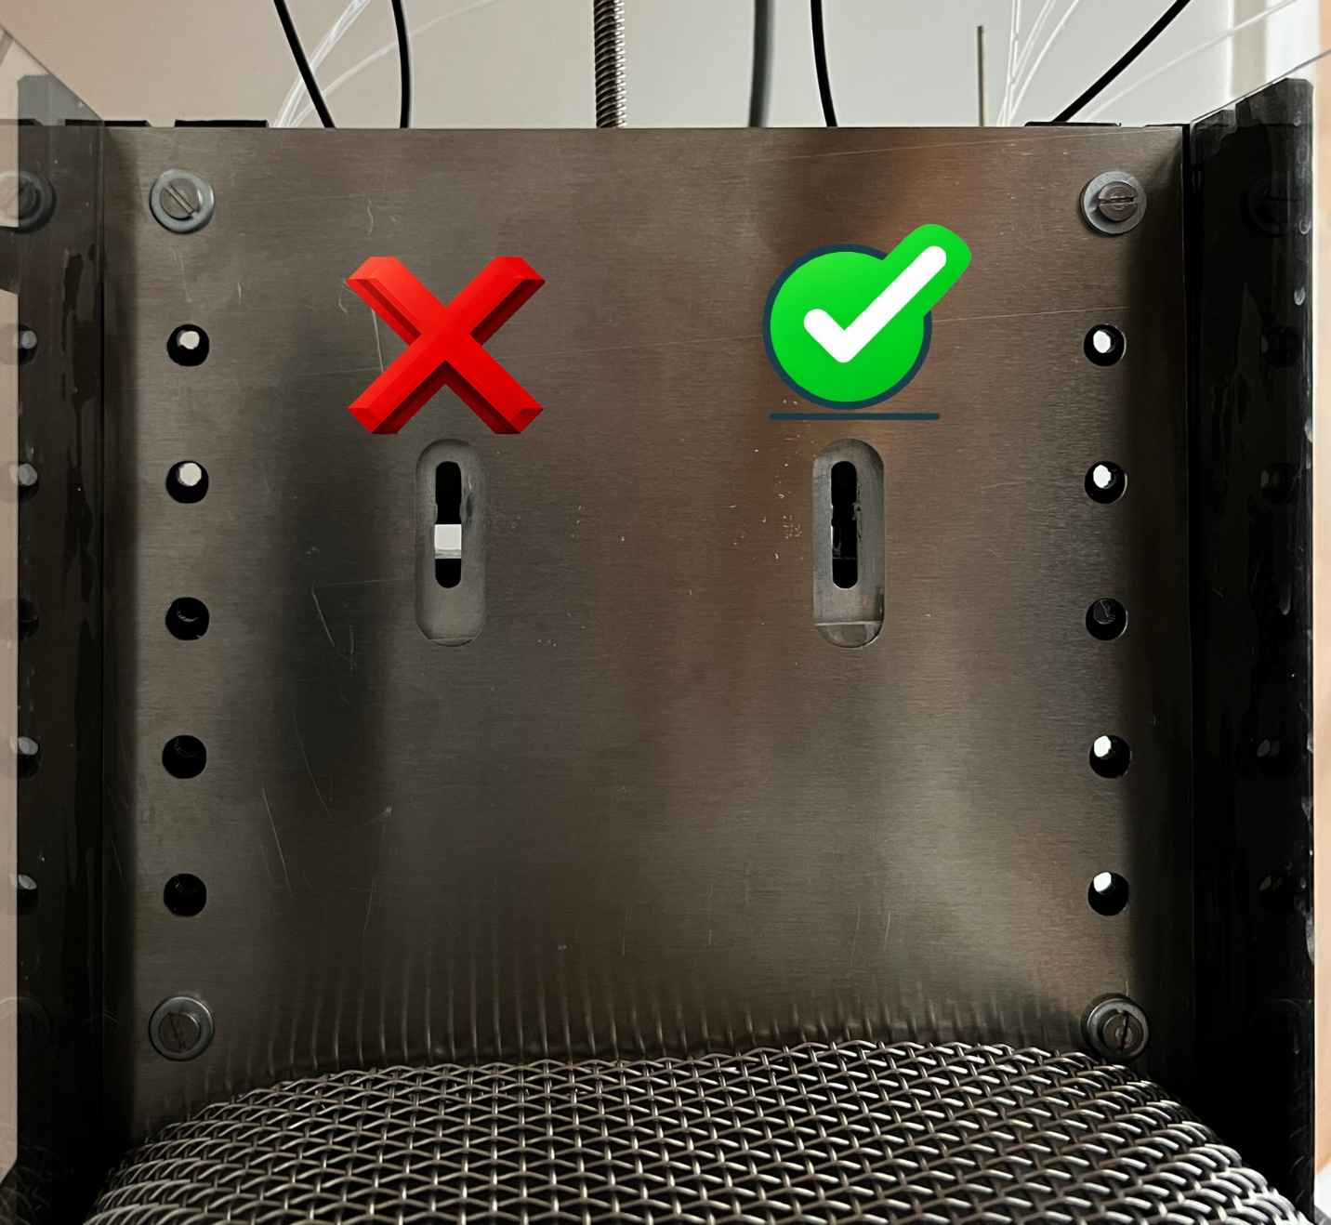

Figure 40

* 1. If both faceplate holes are centered in their corresponding main cage faceplate holes, proceed to step 27g. Otherwise adjustments are needed.
  2. Remove the cage from the breadboard.
  3. Using a 2mm hex wrench (Figure 40), loosen the bolts that retain the spout faceplates to the faceplate arms (Figure 41).

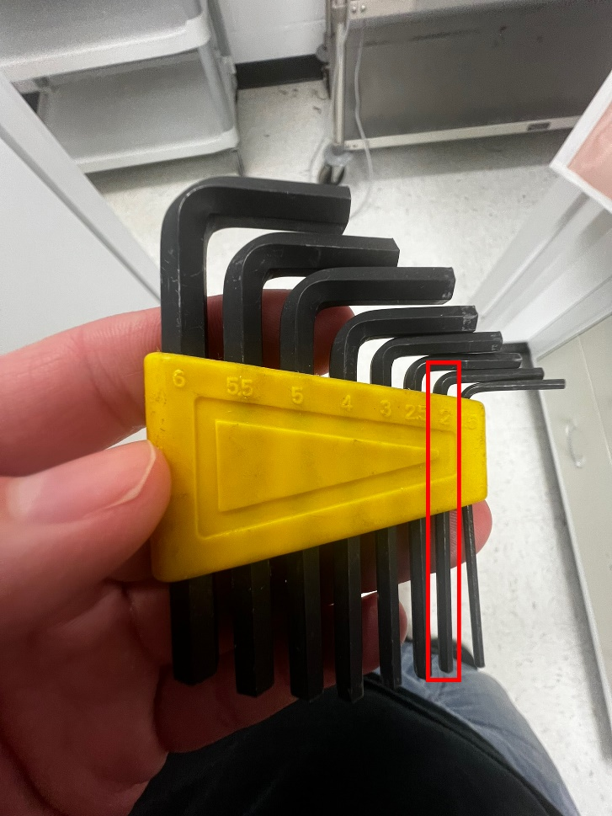

Figure 41

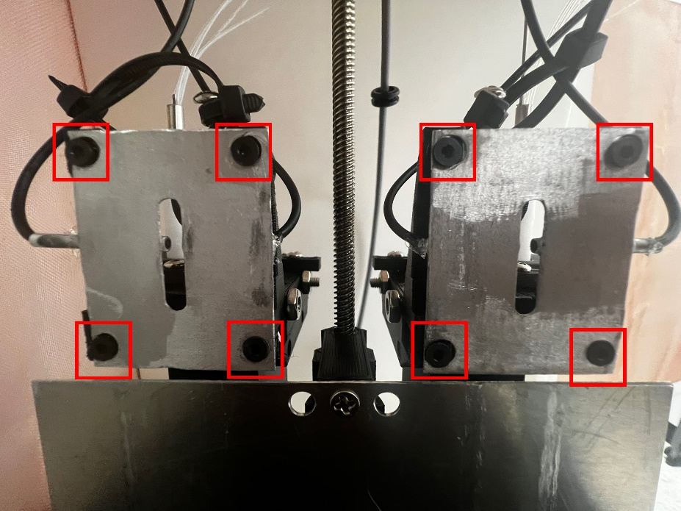

Figure 42

* 1. Adjust the faceplates to align properly with the main faceplate. Typically, the spout faceplate for side one should be adjusted as far left and as far up as possible, while the side two faceplate should be adjusted as far right and as far up as possible. After aligning the faceplates, ensure the faceplate openings remain vertical and are not angled to one side. Hold the faceplate firmly to prevent movement while tightening, and then tighten each of the four faceplate screws by turning them clockwise to prevent future movement.
  2. Move the door back up by clicking the blue *‘Move Motor Up’* button in the ‘Valve Control’ window.

**NOTE:** Anytime you need to move the door up or down for any reason you can return to the ‘Valve Control’ window and use this button to send the command.

1. Place the top on the box by lining up the keys on each of the corner pieces on the top into the slots on the tops of the legs as shown in Figure 43. Repeat the process of tapping each corner down into place until the top is entirely seated on the legs.

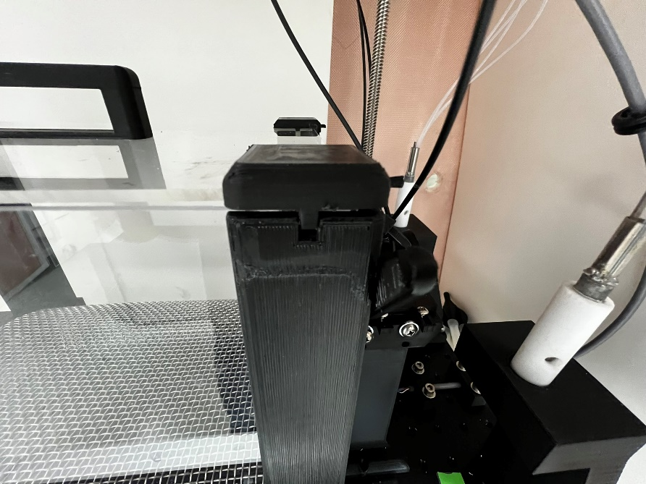

Figure 43

1. Lock the top into place by rotating the latching pieces over top of the keeper assembles as shown in Figure 44 and Figure 45.

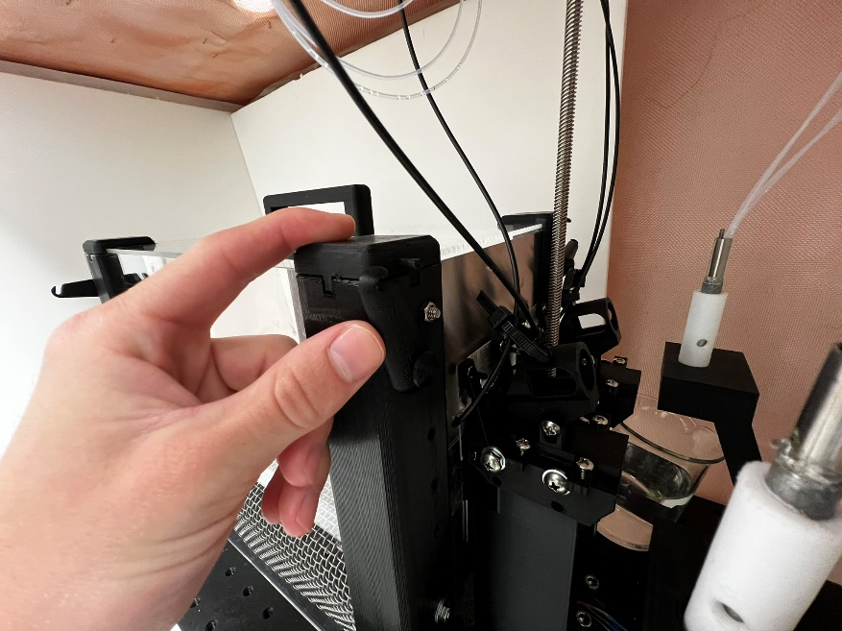

Figure 44

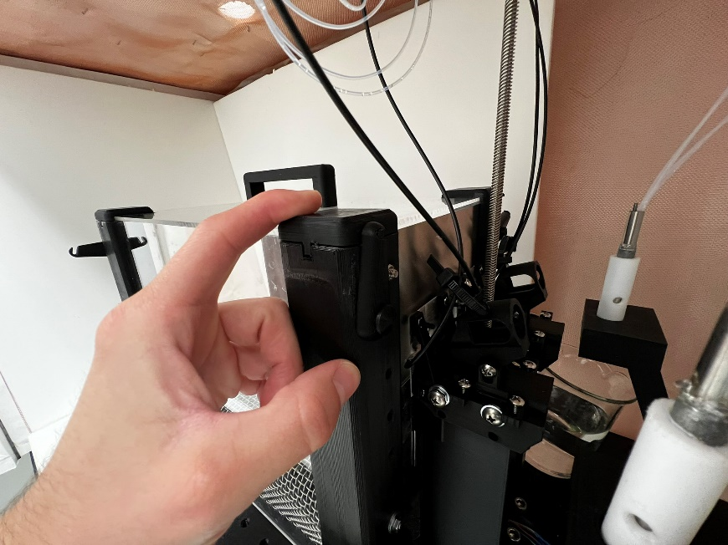

Figure 45

1. Turn the yellow vacuum valve 90 degrees to the on position. It is located at the far end of the counter near the air tank.
2. Modify the experiment parameters shown in the main window. All the time parameters are given in milliseconds. Change these parameters to match the following values:
   1. *ITI Time* (Initial Time Interval Time) -> 30000
   2. *TTC Time* (Time to Contact Time) -> 15000
   3. *Sample Time* -> 15000
   4. *+/- ITI Time* (These times are the maximum values for random time deviation from base values) -> 5000
   5. *+/- TTC Time* -> 0
   6. *+/- Sample Time* -> 0
   7. *# Trial blocks* (# of times that all stimuli pairs will be delivered) -> 10
   8. *# Stimuli*: Total number of unique stimuli used, counting each side separately (e.g., sucrose and saccharin on both sides yields 4 stimuli). -> 4
3. Generate the experiment schedule by assigning stimuli to valves. Click Valves/Stimuli and enter the Stimuli that will go into the valves on side one. The stimuli on side two will automatically be filled in as each valve on the left column is linked directly to the valve to its right. E.g. valves 1 and 5 MUST have the same stimuli, 2 and 6 MUST have the same, etc.
4. Once stimuli have been assigned according to the physical locations of the stimuli, click ‘Generate Schedule’ to generate the schedule for the experiment.
5. The window used to assign the stimuli to the valves can now be closed.
6. All necessary preparations for the experiment have been completed. You can now open the *Rasterized Data* or *Lick Data* windows preemptively and wait for data to come in, or you can just begin the experiment.
7. To begin the experiment, click the big green ***‘Start’*** button.
   1. To monitor trial data such as the stimulus location (side), Inter-Trial Interval (ITI), Time to Contact (TTC), sample time values, and licks for each port during the experiment, access the ‘Program Schedule’ window. If it isn't already open, click on the *‘Program Schedule’* button located in the main application window to open it.
   2. To view Lick Data as it comes in, click *‘Lick Data’* in the main application window. This window will also contain timestamps of when the door has started and finished opening and closing.
   3. To view Rasterized Lick Data, click ‘Rasterized Data in the main application window.
8. Once the experiment is complete, **DO NOT CLOSE THE SOFTWARE.** You need to **save the data** collected by clicking the ‘Save Data’ button in the program's main control window.
   1. A popup will ask you where you would like to save the experiment schedule data sheet, select the folder of your choosing and name the file.
   2. The next popup will ask you where you would like to save the lick and timestamp data sheet, select the folder of your choosing and name the file.
9. Once data has been saved safely for the first run of the experiment, you can now get the software ready for the next rat. To do this, click *Reset* in the main application window. This will close the current window and open a new one, resetting all previous data.
10. **END OF DAY CLEANING**:
    1. Open the ‘Valve Control’ window by pressing the corresponding button in the main application window.
    2. Remove the spouts from their clamping. First, we need to carefully remove the spouts from the clamping assemblies (shown in figure 11), if not already removed. To remove the spout from the clamping assembly:
       1. First remove the vacuum hoses by pulling gently until they slide off the beige threaded inserts (step 1 in Figure 23).
       2. Next, remove the threaded inserts by turning them counterclockwise until they are released from the Teflon tube (step 2 in Figure 23).
       3. Finally, turn the screw on the top of the clamping assembly (counterclockwise to loosen the clamp. Once it has been loosened enough, carefully pull the Teflon tube out of the clamping assembly (step 3 in Figure 23).

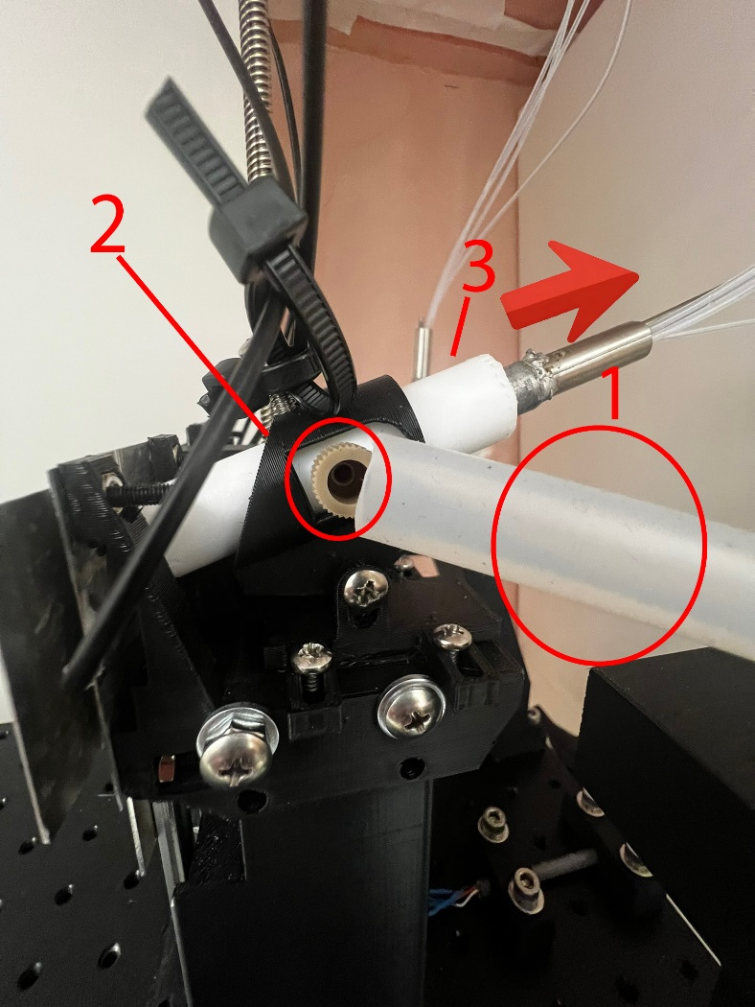

Figure 46

* 1. Insert the spouts into the testing stands on each side.
  2. Place one 250ml beaker under each testing stand as in Figure 23 to catch the liquid dispensed from the spouts.

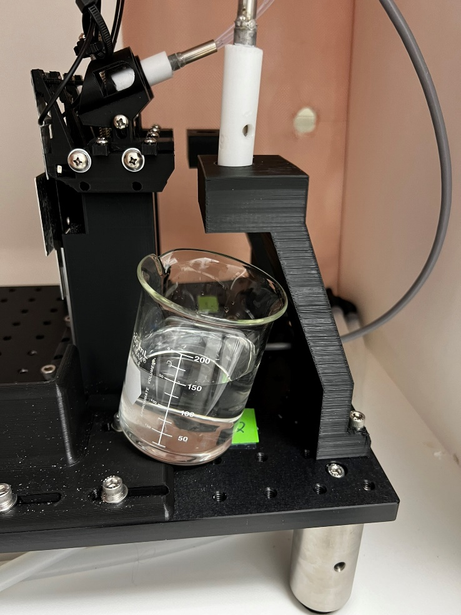

Figure 47

* 1. Cap all the columns by first pressing the Teflon top all the way into place and turning the caps clockwise to tighten them down. All columns must be capped. Make sure the caps are turned tight to avoid a pressure leak from the system.

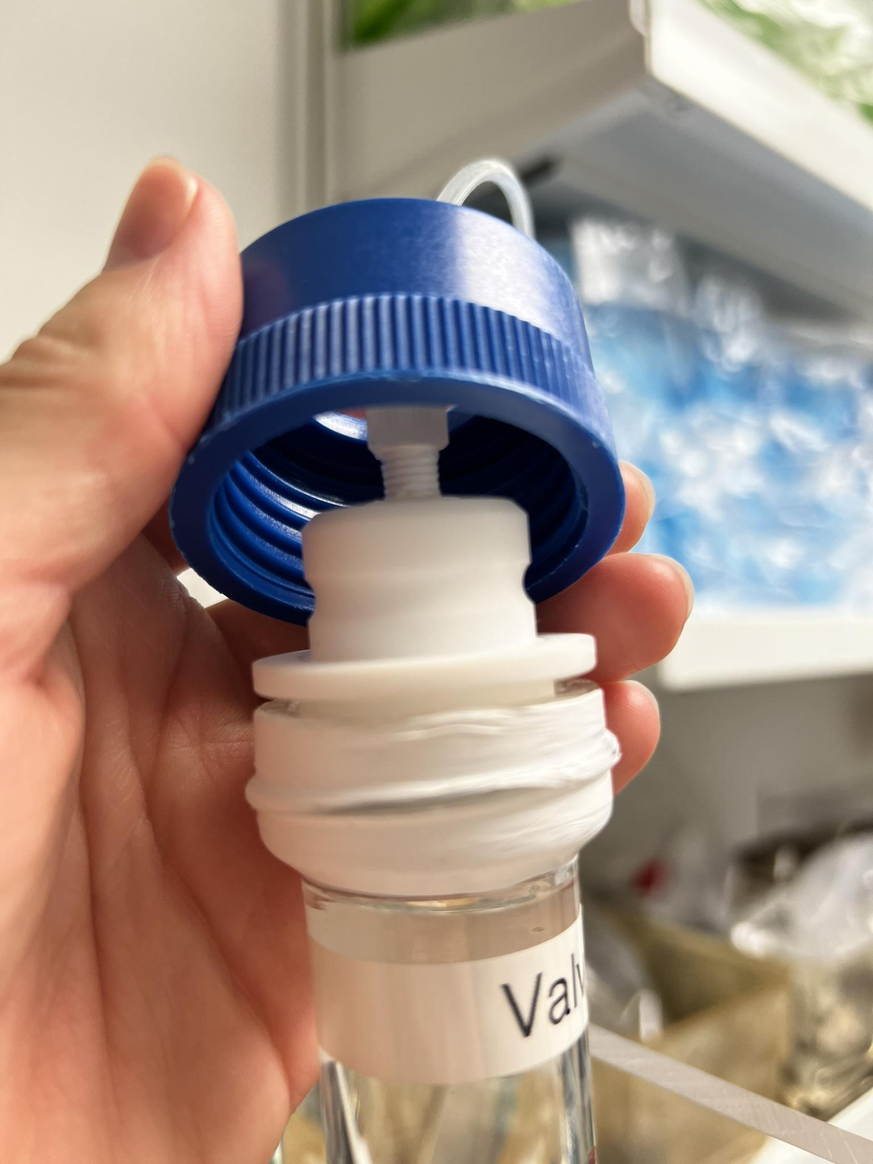

Figure 48

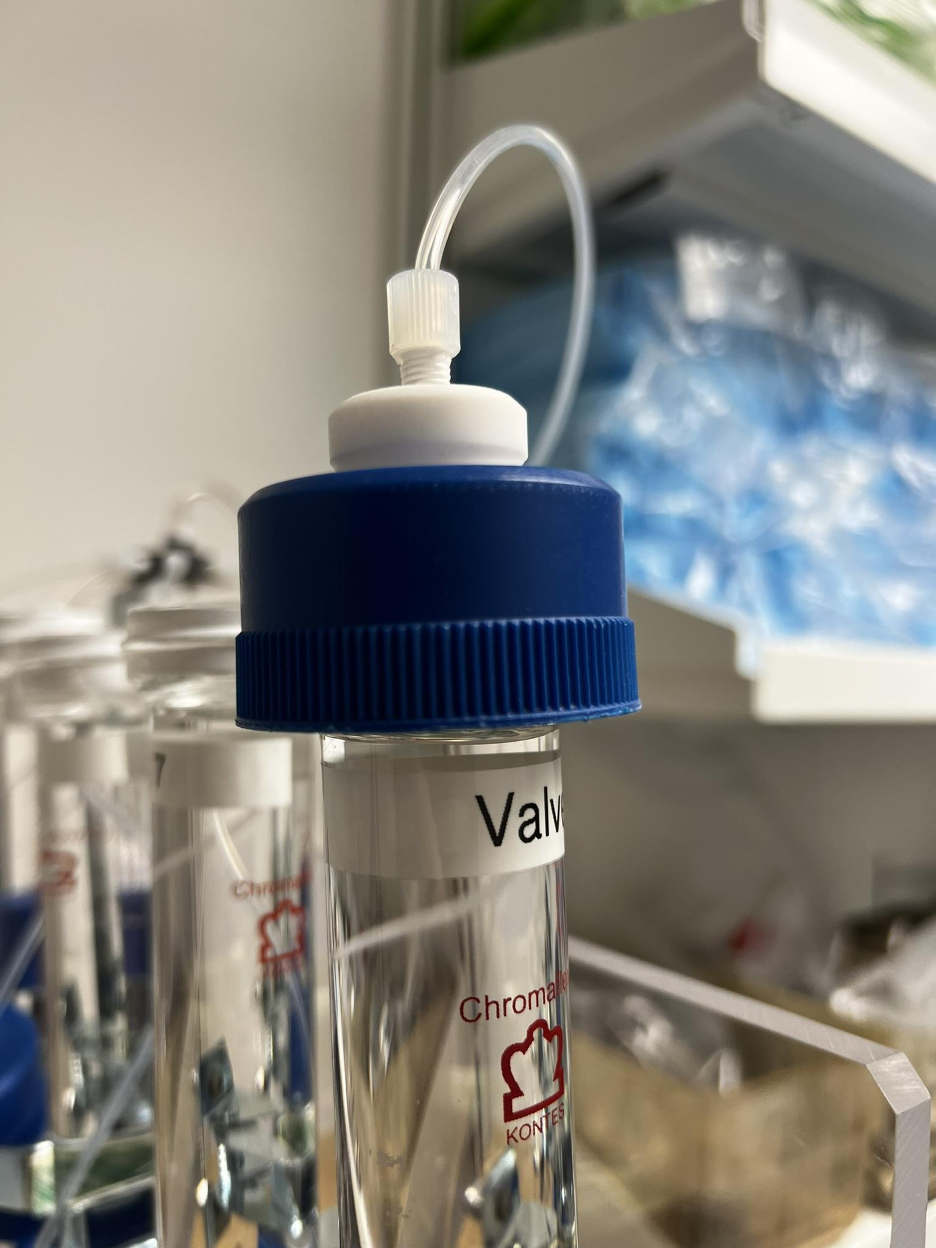

Figure 49

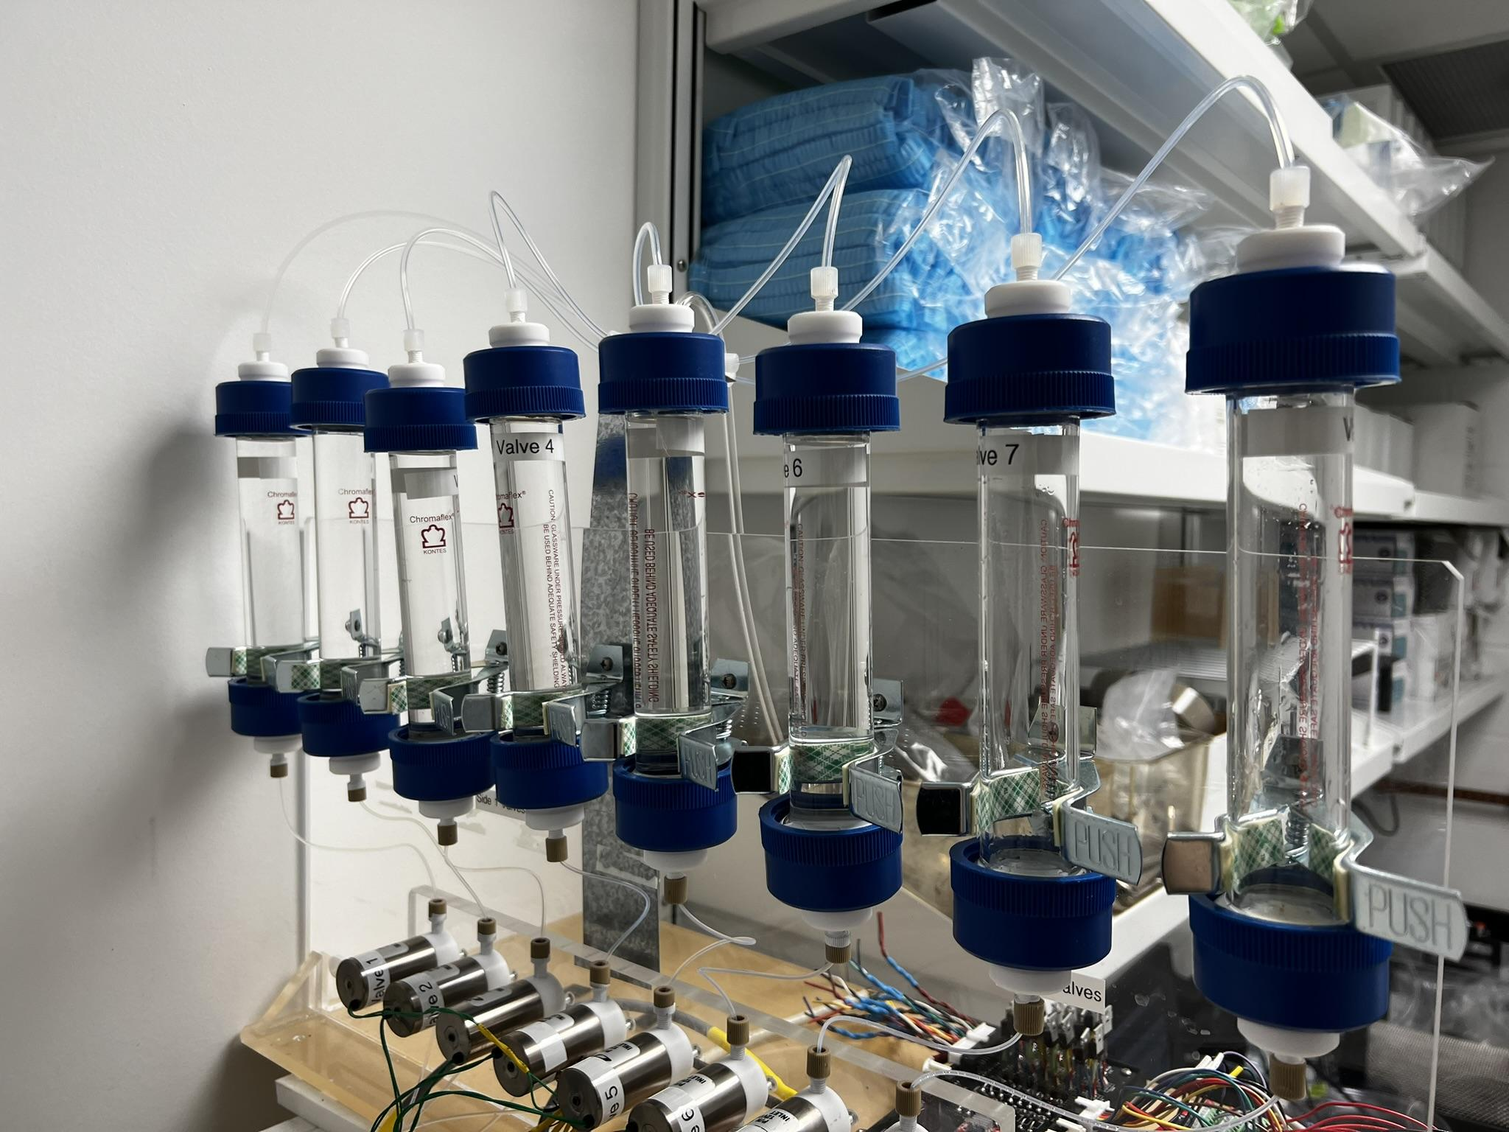

Figure 50

* 1. To pressurize the system, rotate the open/close valve on the Nitrogen tank located at the far end of the room counterclockwise (twisting left in the image below) as shown in Figure 25 approximately three complete turns.



Figure 51

* 1. In the ‘Valve Control’ window you can begin to drain the stimuli from the valves. Drain a maximum of 2 valves per side at a time to avoid overflowing the beakers.
  2. As valves complete the draining process, air will begin to escape, and liquid will splash around the test stand area. To mitigate this, keep an eye on the valves as they drain and click on the corresponding valve in the ‘Valve Control’ software to close the valve when it is fully drained.
  3. Repeat until all valves are drained.
  4. After the stimuli have been drained, remove the caps and tops of the valves and refill with a 70% ethanol / water mixture and repeat steps c through i.
  5. After being cleaned with the ethanol mixture, repeat the process once again with distilled water.

1. The ‘Valve Control’ window can now be closed along with the main window of the program.
2. Press the green *ON/OFF* button on the front of the 12V power supply and flip the switch on the back to completely shut off power to the rig.

***Common Errors Troubleshooting Guide:***

1. Arduino board not establishing a connection with control software.
   1. A problem for both the Laser and Motor Arduino boards when this happens is bad USB connections. Unplugging all USB connections between the Arduino boards and the controller laptop and reseating them can resolve this error. Images of where to reseat connections are shown below.
   2. If the problem persists and the only Arduino causing this error is the Laser Arduino, the issue may be a result of improperly aligned fiber optical cables.
      1. If the lick indicator LEDS are lit for both sides as shown in Figure 52 below, then first check fiber optic cable terminal locations on the spout faceplates. This location is shown in the figures below. The fiber optic cable ends should be flush with the very tip of these tubes on either side as shown clearly in Figure 55 and Figure 56.

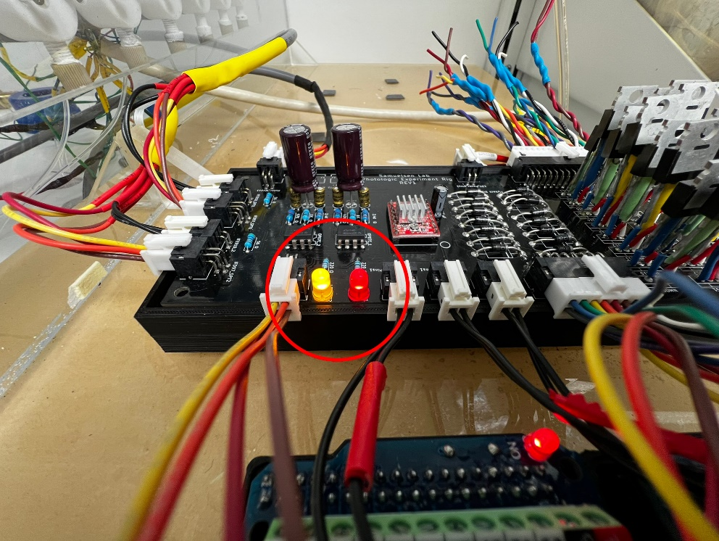

Figure 52

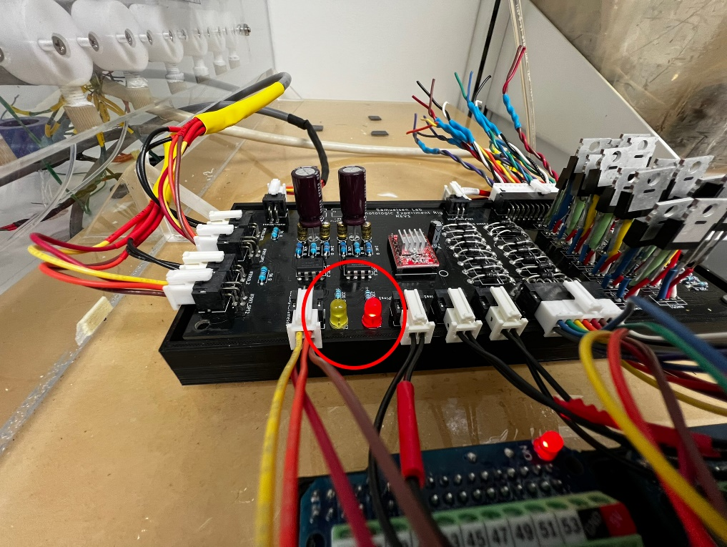

Figure 53

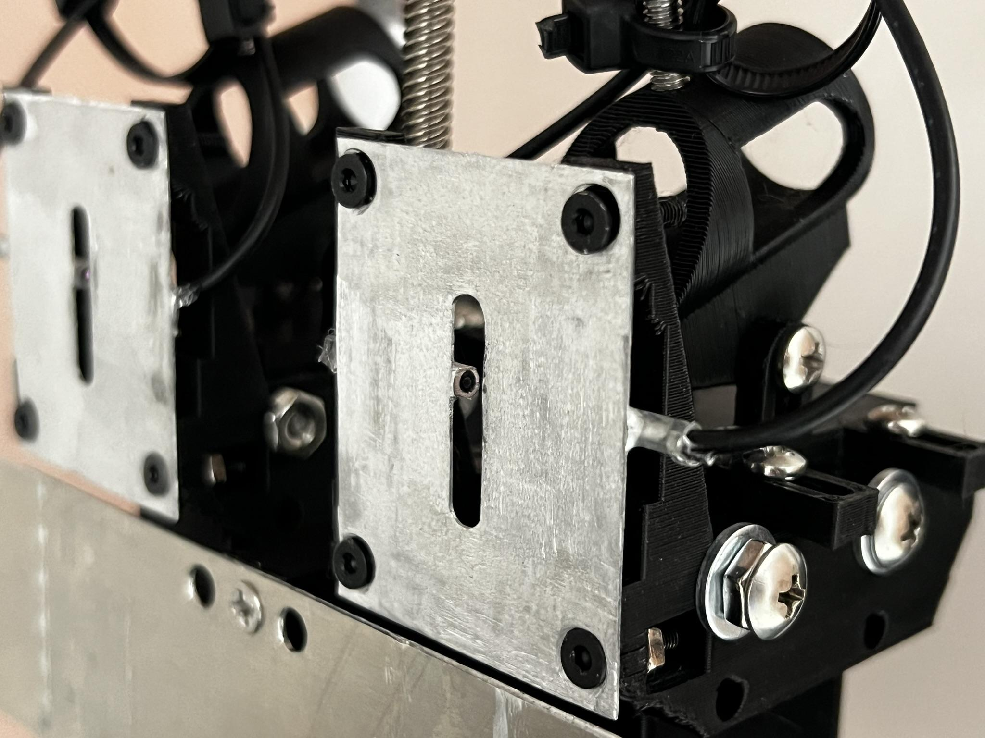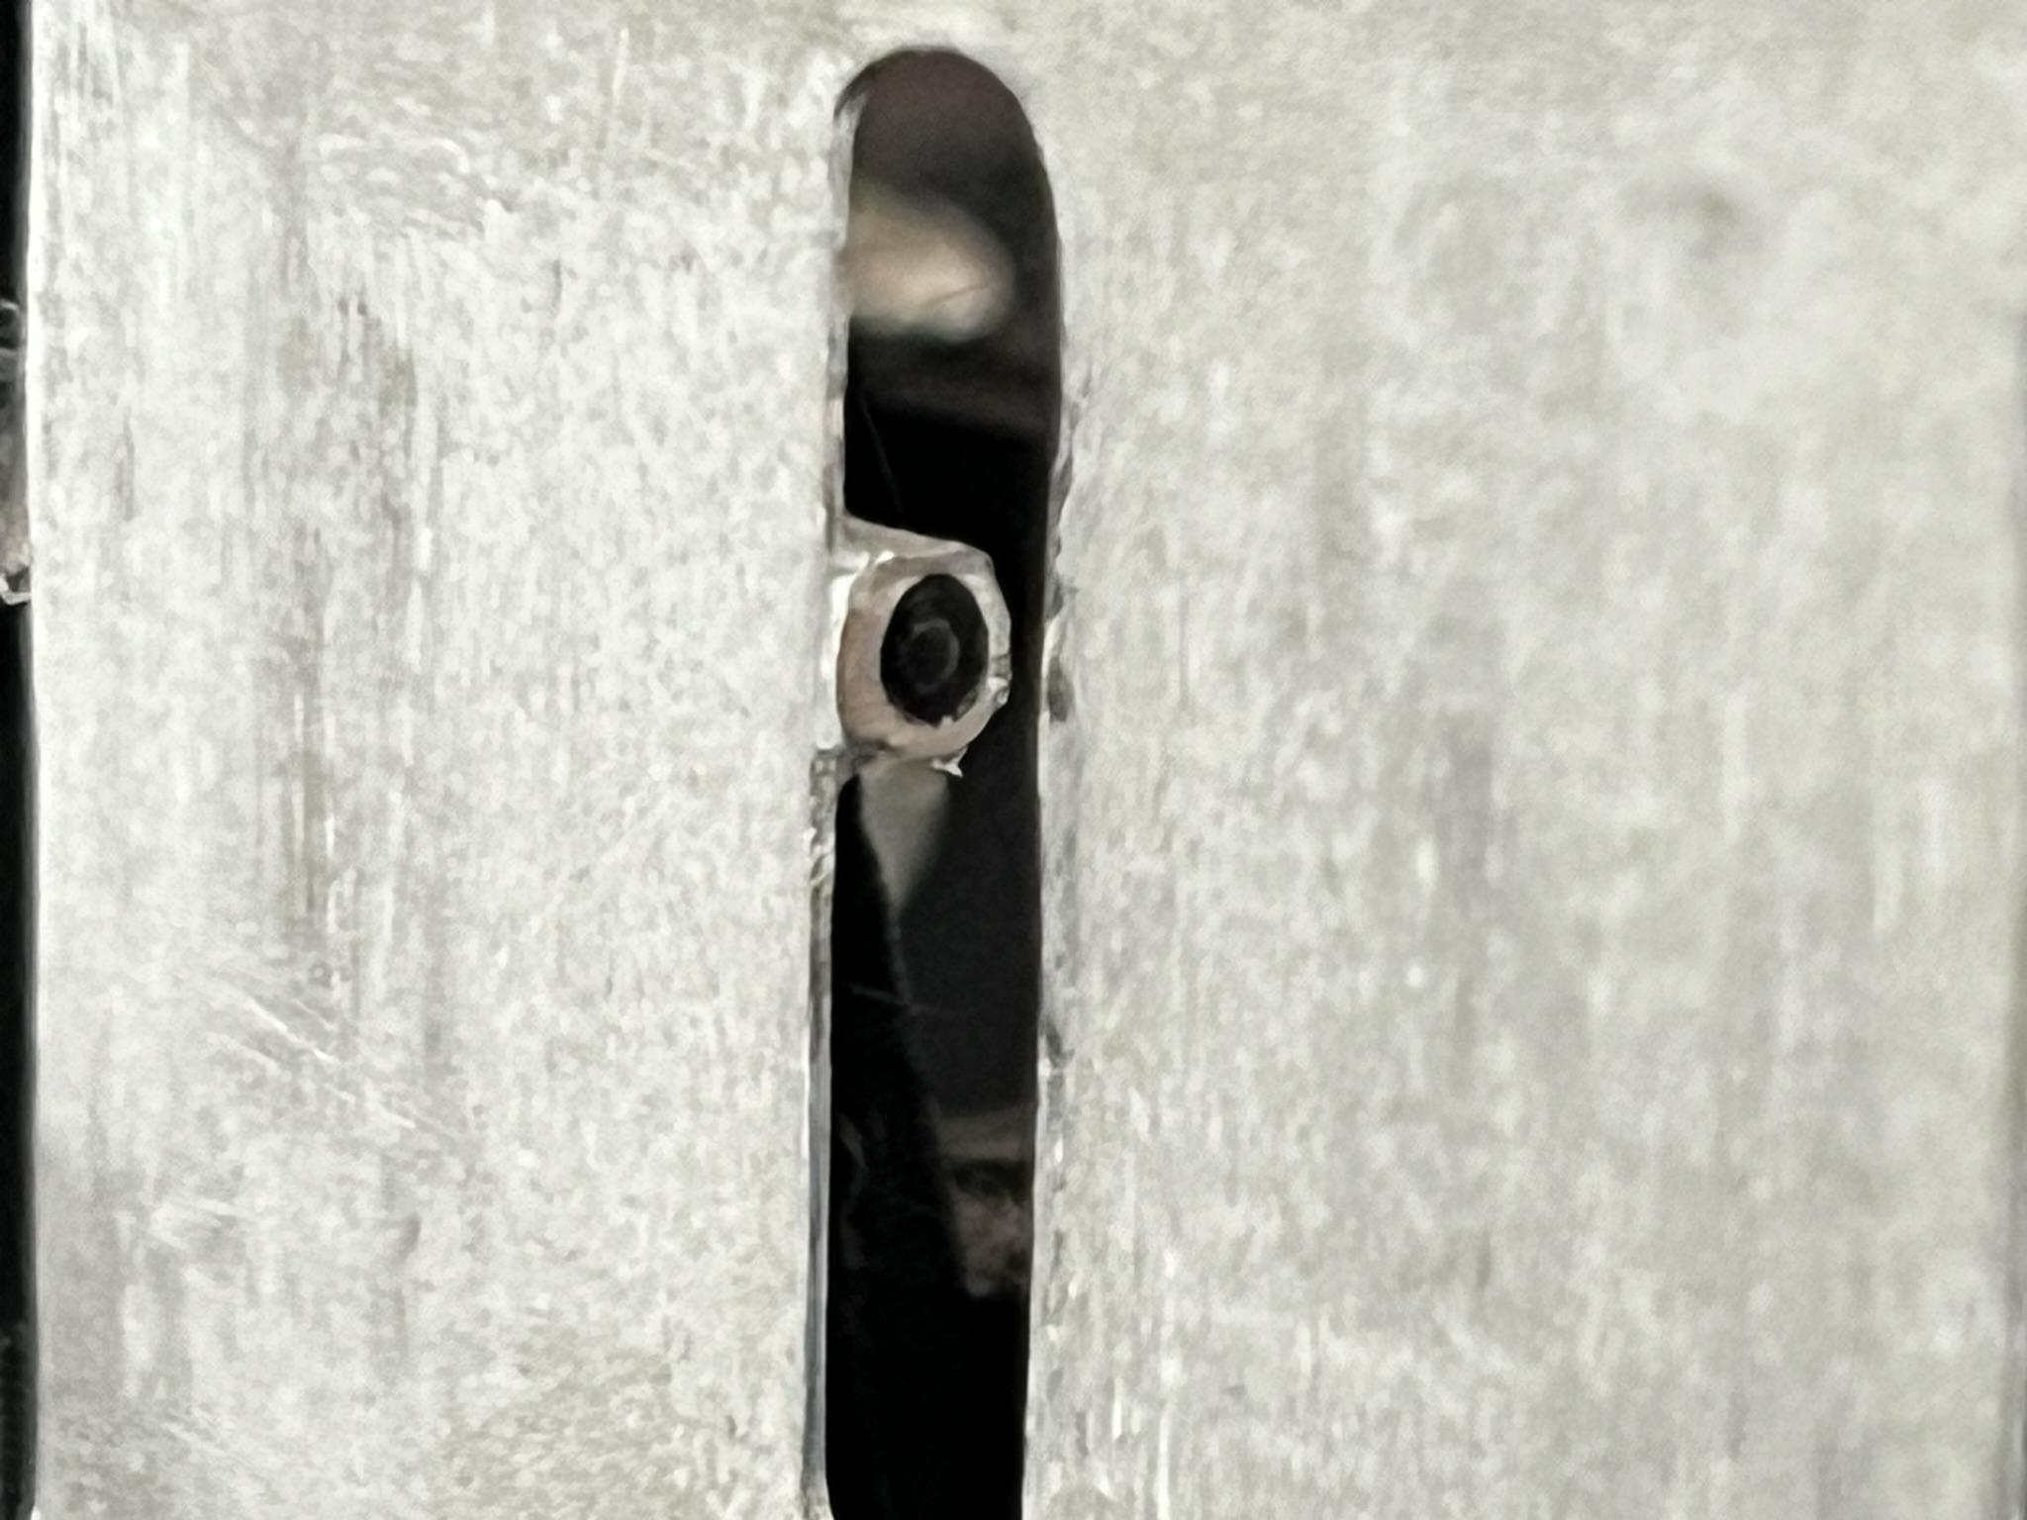

Figure 54

Figure 55

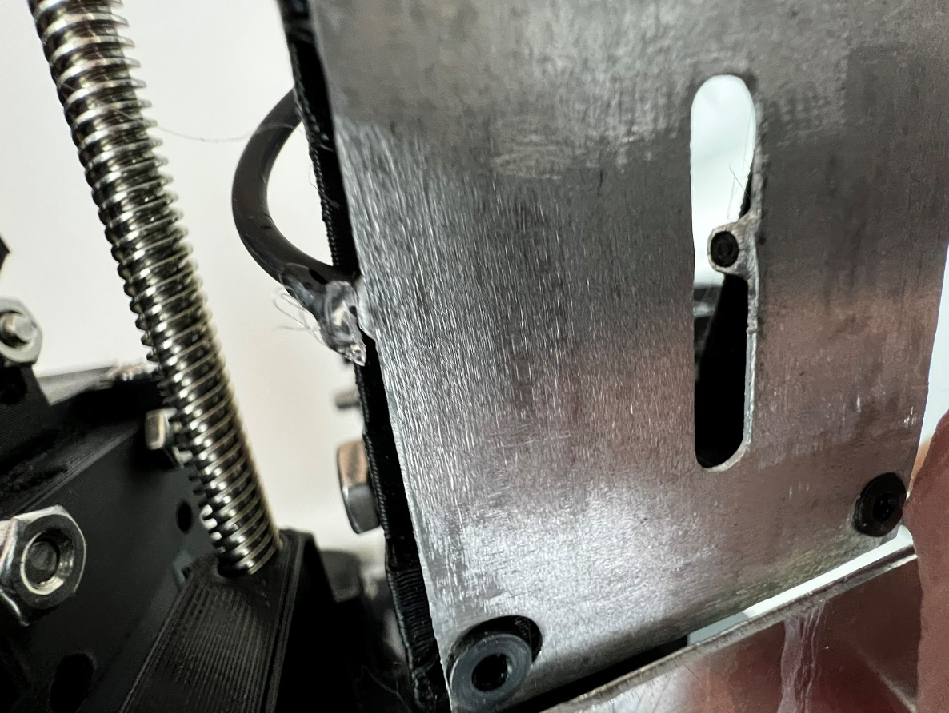

Figure 56

* + 1. Clean off the fiber optic cable ends with a cotton swab (Figure 57) to ensure that all maximal light can pass through the cables unrestricted.

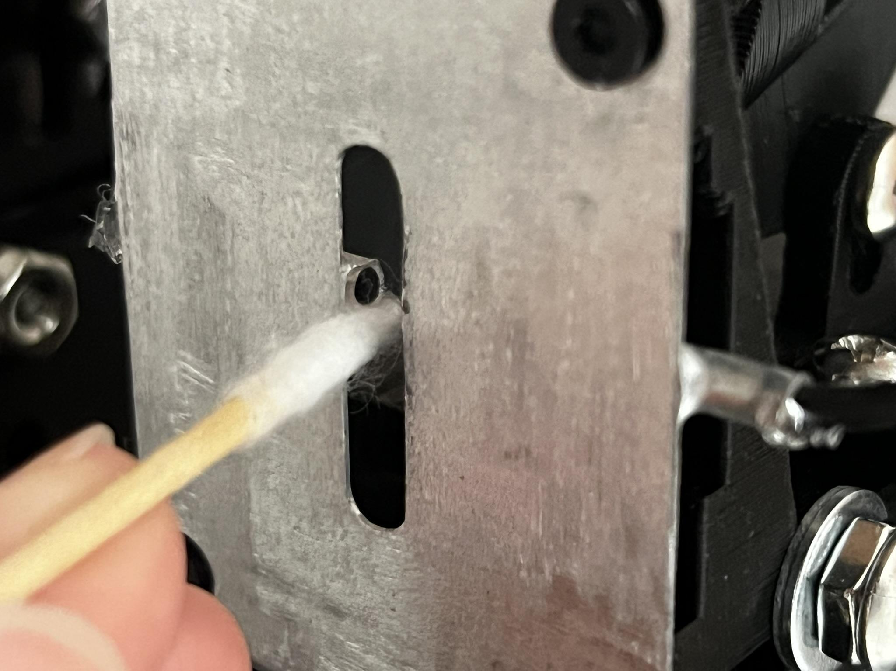

Figure 57

* + 1. If the issue persists, remove, and re-insert the fiber optic cables in the detector and emitter housings to ensure that all light from the emitter is being transmitted to the detector. To Reseat these cables:
       1. Turn the barrel of the LED counterclockwise to loosen the hold on the cable (Figure 58 and Figure 59).
       2. Push the cable back into the housing as far as it will go.
       3. Turn the barrel clockwise to tighten it down.

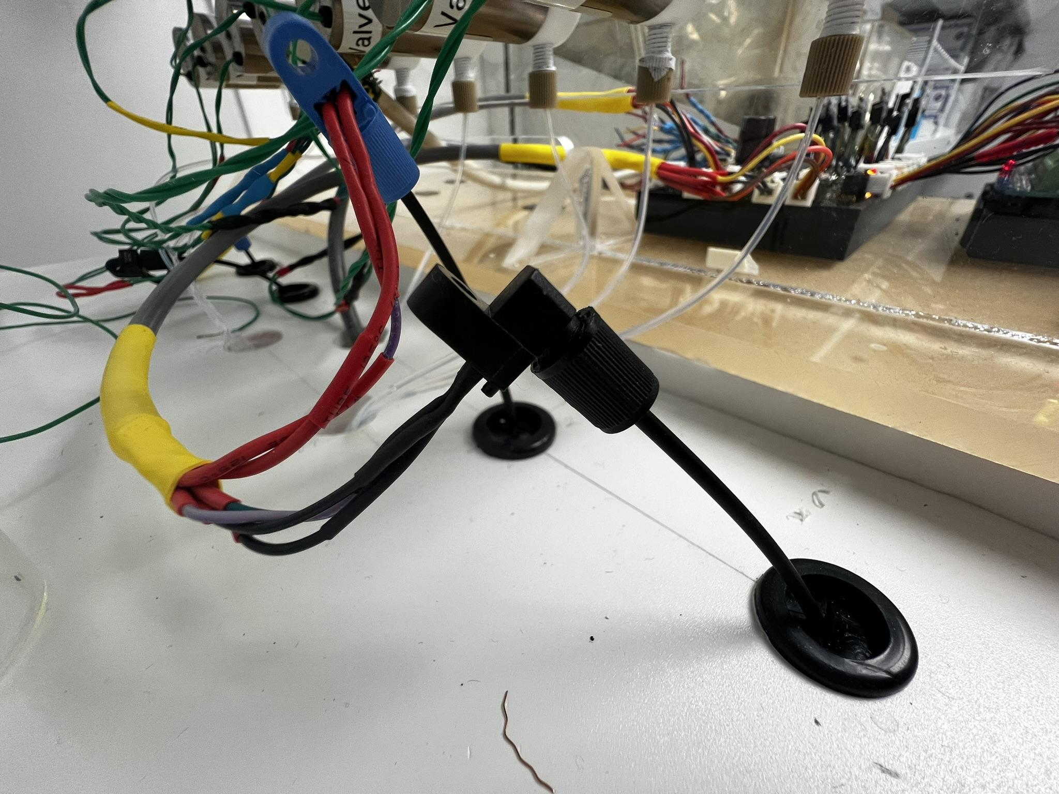

Figure 58

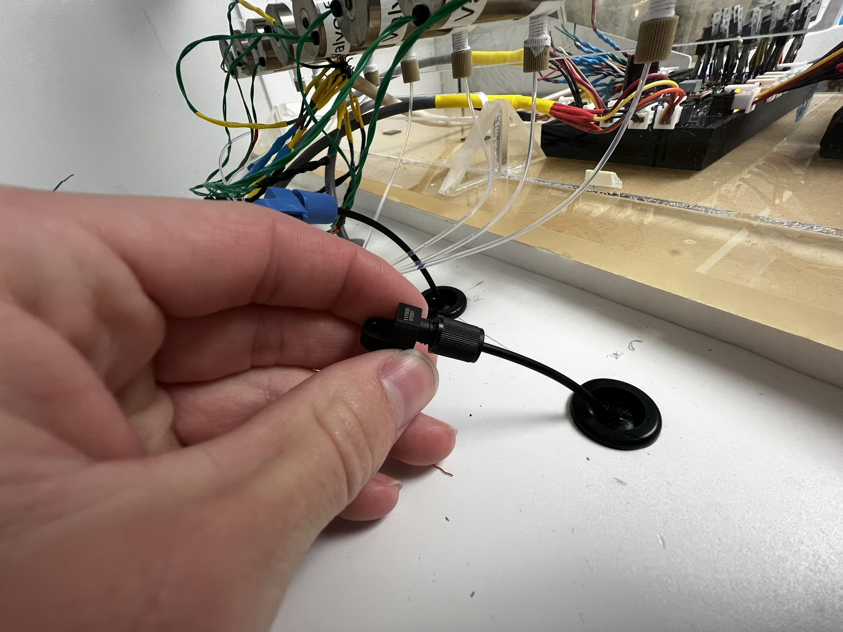

Figure 59